Kinchant Dam Outdoor Education Centre
High Ropes
Activity Overview Years 7-10
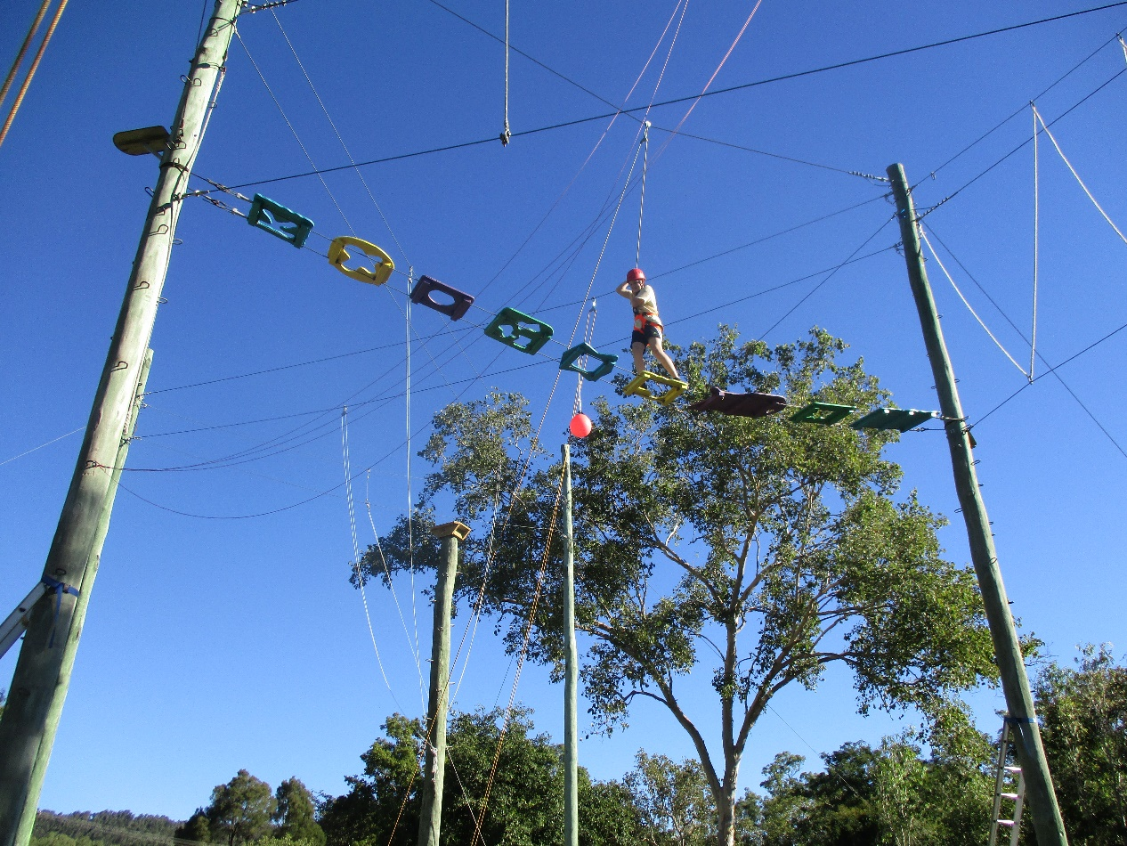
Activity Objective (Aim): Students will participate in a high ropes activity to strengthen their understanding of the core focus objectives that align with the school’s chosen program.

Program Core Focus Objectives
Team Work  Cooperation  Negotiating  Participation  Reflecting  Goal Setting  Have Team Roles and Responsibility  Respect  Building Trust  Being reliable  Accepting Diversity  Communication  Active Listening  Speaking Clearly |  | Leadership  Responsible  Being Accountable  Self-Confident  Knowing your strengths and Weaknesses  Having Courage to Take Control  Decisive  Being decisive  Resourceful  Being inclusive |  | Resilience  Self Control  Avoid Frustration  Control their emotions appropriately  Optimism  Look at the bright side  Have a positive outlook  Have a sense of self-belief and remind themselves of the things they can do  Adaptable  Think ahead  Don’t blame others  Seek opportunities from failure  Perseverance  Give new tasks a go  When something doesn’t work the first time give it another go (be flexible)  Overcome obstacles  Support  Ask for help  Be trustworthy and dependable  Take care of themselves and others, have social networks form where you can seek support
Evidence of Learning:
Team Work  Students can  - Negotiate their personal limits  - Make informed personal decisions  - Reflect on their personal experience  - Set goals to achieve greater personal targets  - Know their roles and responsibilities within the team  - Build trust amongst their group to ensure both physical and emotional safety  - Be trusted to complete their designated responsibilities  - Accept that different group members have different limitations  - Demonstrate purposeful listening  - Communicate effectively with team members |  | Leadership  Students can  - Think before they act  - Take actions to prevent or correct problems  - Accept responsibility  - Take care of their team  - Know what they are good at  - Know what they need help with  - Seek help from the right person  - Speak up when it is needed and listen all of the time  - Clearly understand the goal  - Collect all relevant information  - Consider the needs of the team  - Help people share their ideas  - Find relevant jobs for everyone involved |  | Resilience  Students can  - Identify situations that lead to stress  - Identify appropriate strategies to manage stress and regulate behaviour  - Implement appropriate strategies to manage stress and moderate emotions  - Understand the difference between appropriate and inappropriate emotions  - Understand the impact of their emotional responses on others  - Demonstrate appropriate emotions  - Identify situations where emotions can negatively impact on your actions  - Identify the positive in a given situation  - Perceive negative situations as opportunities for growth  - Reflect on smaller achievements rather than whether or not overall success was achieved  - Share achievements with others  - Use positive language to describe challenges  - Identify their own strengths  - Seek opportunities to develop strengths  - Use positive self-talk  - Set goals for personal learning  - Use a growth mindset  - Use prior knowledge to express possible solutions  - Determine what they want to plan for  - Identify previously learnt skills that could be used to reach a solution  - Identify and describe factors and strategies that assist in their learning  - Be accountable for their actions  - Seek solutions rather than blame  - Practise solving routine problems  - Learn from mistakes  - Analyse past attempts  - Predict the outcomes of personal and academic challenges by drawing on previous problem-solving and decision making strategies and feedback from peers and teachers  - Identify unfamiliar situations  - Undertake and persist with short tasks within the limits of personal safety  - Have the courage to try unfamiliar challenges  - Reflect on unfavourable outcomes to understand why results were not achieved  - Persist with tasks when faced with challenges  - Adapt their approach where first attempts were not successful  - Monitor and evaluate progress  - Seek and respond to feedback  - Analyse progress to reflect on possible solutions  - Devise strategies and formulate plans to assists in the completion of challenging tasks  - Identify situations that feel safe or seemingly unsafe, approaching new situations with confidence
Curriculum Links: Teamwork, Leadership and Resilience
HPE |  |  | HASS
Movement and Physical Activity  Evaluate and justify reasons for decisions and choices of action when solving movement challenges  (ACPMP087)  Use feedback to improve body control and coordination when performing specialised movement skills in a variety of situations  (ACPMP080)  Practise and apply personal and social skills when undertaking a range of roles in physical activities (ACPMP086)  Develop, implement and evaluate movement concepts and strategies for successful outcomes with and without equipment  (ACPMP101)  Devise, implement and refine strategies demonstrating leadership and collaboration skills when working in groups or teams  (ACPMP105)  Transfer understanding from previous movement experiences to create solutions to movement challenges  (ACPMP106)  Personal Social and Community Health  Investigate and select strategies to promote health, safety and wellbeing  (ACPPS073)  Analyse factors that influence emotions, and develop strategies to demonstrate empathy and sensitivity. (ACPPS075)  Evaluate factors that shape identities and critically analyse how individuals impact the identities of others (ACPPS089)  Propose, practise and evaluate responses in situations where external influences may impact on their ability to make healthy and safe choices  (ACPPS092)  Investigate how empathy and ethical decision making contribute to respectful relationships  (ACPPS093) |  |  | Civics and Citizenship Skills  Appreciate multiple perspectives and use strategies to mediate differences  (ACHCS057)  Appreciate multiple perspectives and use strategies to mediate differences  (ACHCS071)  Account for different interpretations and points of view (ACHCS098)
General Capabilities
Personal and Social Capability |  |  | Critical and Creative Thinking
Self-awareness  • Recognise personal qualities and achievements  • Understand themselves as learners  • Develop reflective practice  • Recognise emotions  Self-management  • Express emotions appropriately  • Develop self-discipline and set goals  • Become confident, resilient and adaptable  • Express emotions appropriately  Social awareness  • Appreciate diverse perspectives  Social management  • Work collaboratively  • Make decisions  • Communicate effectively |  |  | Inquiring – identifying, exploring and organising information and ideas  - Identify and clarify information and ideas  - Organise and process information  - Pose questions  Generating ideas, possibilities and actions  - Seek solutions and put ideas into action  - Draw conclusions and design a course of action  Reflecting on thinking and processes  - Reflect on processes  - Transfer knowledge into new contexts  Analysing, synthesising and evaluating reasoning and procedures  - Apply logic and reasoning  - Evaluate procedures and outcomes.

