Giant Swing | Kinchant Dam Outdoor Education Centre  Giant Swing
Activity Overview Years 5-6
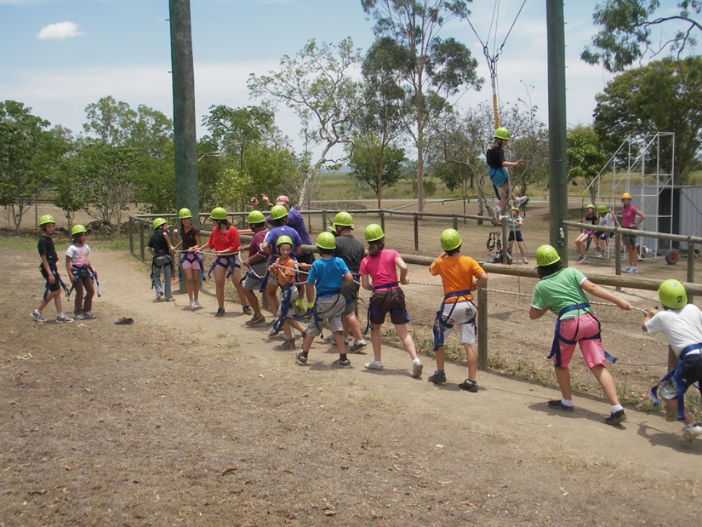

Activity Objective (Aim): Students will participate in a giant swing activity to strengthen their understanding of the core focus objectives that align with the school’s chosen program.

Program Core Focus Objectives
Team Work  Cooperation  Negotiation  Decision Making  Participation  Reflecting  Goal Setting  Respect  Building Trust  Accepting Diversity  Communication  Active Listening |  |  | Resilience  Self Control  Avoid Frustration  Control their emotions appropriately  Perseverance  Give new tasks a go  When something doesn’t work the first time give it another go (be flexible)  Overcome obstacles  Support  Ask for help  Be trustworthy and dependable  Take care of themselves and others, have social networks form where you can seek support
Evidence of Learning:
Teamwork  Students can  - Negotiate their personal limits.  - Make informed personal decisions.  - Reflect on their personal experience.  - Set goals to achieve greater personal targets.  - Build trust amongst their activity group to ensure emotional safety.  - Accept that different group members have different limitations.  - Demonstrate purposeful listening |  | Resilience  Students can  - Identify situations that lead to stress  - Identify appropriate strategies to manage stress and regulate behaviour  - Implement appropriate strategies to manage stress and moderate emotions  - Understand the difference between appropriate and inappropriate emotions  - Understand the impact of their emotional responses on others  - Demonstrate appropriate emotions  - Identify situations where emotions can negatively impact on your actions  - Identify unfamiliar situations  - Undertake and persist with short tasks within the limits of personal safety  - Have the courage to try unfamiliar challenges  - Reflect on unfavourable outcomes to understand why results were not achieved  - Persist with tasks when faced with challenges  - Adapt their approach where first attempts were not successful  - Monitor and evaluate progress  - Seek and respond to feedback  - Analyse progress to reflect on possible solutions  - Devise strategies and formulate plans to assists in the completion of challenging tasks  - Identify situations that feel safe or seemingly unsafe, approaching new situations with confidence  - Identify own strength as well as group strengths that can be useful in achieving goals  - Seek and respond to feedback  - Know who they can go to for help  - Ask an appropriate person for assistance  - Discuss elements of a task that they are unsure about  - Specifically articulate what they are seeking  - Identify positive ways to initiate conversations (interpersonal skills)  - Identify people and situations with which the feel a sense of familiarity or belonging  - Respond to the feelings, needs and interests of others  - Be cooperative  - Be sincere – say what you mean and mean what you say  - Be reliable  - Own up to mistakes  - Describe factors that contribute to positive relationships  - Identify and explain factors that influence effective communication  - Describe characteristics of cooperative behaviour  - Identify evidence of positive behaviour in group activities  - Assess the extent to which individual roles and responsibilities enhance group cohesion and the achievement of personal and group objectives  - Assess individual and group decision making processes
Curriculum Links: Teamwork and Resilience
HPE |  | HASS
Movement and Physical Activity  Manipulate and modify elements of effort, space, time, objects and people to perform movement sequences (ACPMP065)  Participate positively in groups and teams by encouraging others and negotiating roles and responsibilities  (ACPMP067)  Demonstrate ethical behaviour and fair play that aligns with rules when participating in a range of physical activities  (ACPMP069)  Apply critical and creative thinking processes in order to generate and assess solutions to movement challenges (ACPMP068) |  | Inquiry and Skills  Work in groups to generate responses to issues and challenges  (ACHASSI102)  Reflect on learning to propose personal and/or collective action in response to an issue or challenge  (ACHASSI104)  Examine different viewpoints on actions, events, issues and phenomena in the past and present  (ACHASSI127)  Work in groups to generate responses to issues and challenges  (ACHASSI130)  Reflect on learning to propose personal and/or collective action in response to an issue or challenge, and predict the probable effects  (ACHASSI132)
General Capabilities
Personal and Social Capability |  | Critical and Creative Thinking
Self-awareness  • Recognise personal qualities and achievements  • Develop reflective practice  • Understand themselves as learners  • Recognise emotions  Self-management  • Express emotions appropriately  • Develop self-discipline and set goals  • Become confident, resilient and adaptable  Social management  • Communicate effectively  • Work collaboratively  • Make decisions  Social awareness  • Appreciate diverse perspectives  • Work collaboratively  • Make decisions |  | Inquiring, identifying, exploring and organising information and ideas  • Pose Questions  Reflecting on thinking and processes  • Reflect on the process  • Transfer knowledge into a new context

