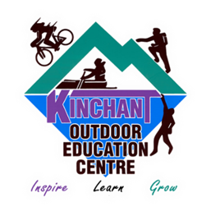 |  | Kinchant Dam Outdoor Education Centre  Raft Building
Activity Overview Years 3-6
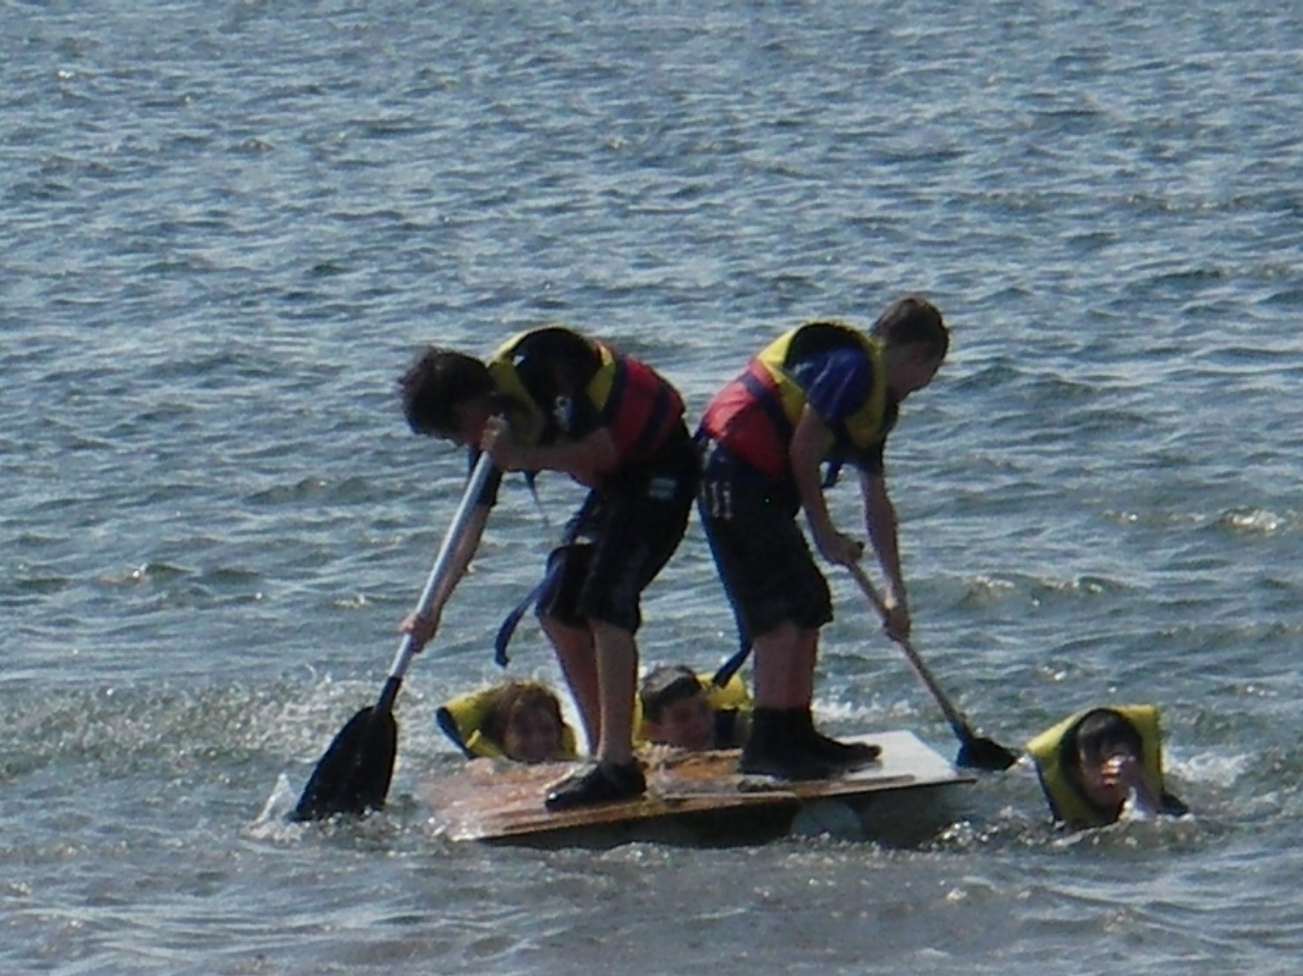
Activity Objective (Aim): Students will participate in a raft building activity session to strengthen their understanding of the core focus objectives that align with the school’s chosen program.

Program Core Focus Objectives
Team Work  Cooperation  Problem Solving  Negotiating  Decision Making  Participation  Team Roles and Responsibilities  Goal Setting  Reflecting  Respect  Being Reliable  Accepting Diversity  Communication  Active Listening  Speaking Clearly  Using Purposeful Discussion |  |  | Leadership  Responsible  Being Accountable  Good Self-Management Skills  Self-Confident  Knowing your strengths and Weaknesses  Having Courage to Take Control  Supporting New and Innovative Strategies  Decisive  Creating a Plan  Resourceful |  |  |  | Resilience  Self Control  Avoid Frustration  Control their emotions appropriately  Put off small short term gains to achieve greater long term goals  Optimism  Look at the bright side  Have a positive outlook  Have a sense of self-belief and remind themselves of the things they can do  Adaptable  Think ahead  Don’t blame others  Seek opportunities from failure  Perseverance  Give new tasks a go  When something doesn’t work the first time give it another go (be flexible)  Overcome obstacles  Support  Ask for help  Be trustworthy and dependable  Take care of themselves and others, have social networks form where you can seek support
Evidence of Learning:
Team Work  Students can  - Analyse the problem  - Plan a solution  - Implement solutions  - Negotiate their personal limits  - Make informed personal decisions  - Reflect on their personal experience  - Set roles and responsibilities within their team  - Set goals to achieve greater personal targets  - Know their roles and responsibilities within the team  - Build trust amongst their group to ensure both physical and emotional safety  - Be trusted to complete their designated responsibilities  - Accept that different group members have different limitations  - Demonstrate purposeful listening  - Communicate effectively with team members |  |  | Leadership  Students can  - Think before they act  - Take actions to prevent or correct problems  - Accept responsibility  - Take care of their team  - Know what they are good at  - Know what they need help with  - Seek help from the right person  - Speak up when it is needed and listen all of the time  - Clearly understand the goal  - Collect all relevant information  - Consider the needs of the team  - Help people share their ideas  - Find out what people know and can do  - Find relevant jobs for everyone involved  - Encourage people to think differently and try new things |  |  |  | Resilience  Students Can  - Identify situations that lead to stress  - Identify appropriate strategies to manage stress and regulate behaviour  - Implement appropriate strategies to manage stress and moderate emotions  - Understand the difference between appropriate and inappropriate emotions  - Understand the impact of their emotional responses on others  - Demonstrate appropriate emotions  - Identify situations where emotions can negatively impact on your actions  - Look at situations holistically  - Identify opportunities for goal setting  - Understand possible outcomes  - Identify personal strengths and challenges  - Make realistic assessments of personal strengths and abilities  - Set goals appropriately taking into account timelines, abilities and possible setbacks  - Reflect on personal strengths and achievements when assessing whether goals were met  - Differentiate between long and short term goals  - Identify benefits of achieving goals  - Identify the positive in a given situation  - Perceive negative situations as opportunities for growth  - Reflect on smaller achievements rather than whether or not overall success was achieved  - Share achievements with others  - Use positive language to describe challenges  - Identify their own strengths  - Seek opportunities to develop strengths  - Use positive self-talk  - Set goals for personal learning  - Use a growth mindset  - Use prior knowledge to express possible solutions  - Determine what they want to plan for  - Identify previously learnt skills that could be used to reach a solution  - Identify and describe factors and strategies that assist in their learning  - Be accountable for their actions  - Seek solutions rather than blame  - Practise solving routine problems  - Learn from mistakes  - Analyse past attempts  - Predict the outcomes of personal and academic challenges by drawing on previous problem-solving and decision making strategies and feedback from peers and teachers  - Identify unfamiliar situations  - Undertake and persist with short tasks within the limits of personal safety  - Have the courage to try unfamiliar challenges  - Reflect on unfavourable outcomes to understand why results were not achieved  - Persist with tasks when faced with challenges  - Adapt their approach where first attempts were not successful  - Monitor and evaluate progress  - Seek and respond to feedback  - Analyse progress to reflect on possible solutions  - Devise strategies and formulate plans to assists in the completion of challenging tasks  - Identify situations that feel safe or seemingly unsafe, approaching new situations with confidence  - Identify own strength as well as group strengths that can be useful in achieving goals  - Seek and respond to feedback  - Know who they can go to for help  - Ask an appropriate person for assistance  - Discuss elements of a task that they are unsure about  - Specifically articulate what they are seeking  - Identify positive ways to initiate conversations (interpersonal skills)  - Identify people and situations with which the feel a sense of familiarity or belonging  - Respond to the feelings, needs and interests of others  - Be cooperative  - Be sincere – say what you mean and mean what you say  - Be reliable  - Own up to mistakes  - Describe factors that contribute to positive relationships  - Identify and explain factors that influence effective communication  - Describe characteristics of cooperative behaviour  - Identify evidence of positive behaviour in group activities  - Assess the extent to which individual roles and responsibilities enhance group cohesion and the achievement of personal and group objectives  - Assess individual and group decision making processes
Curriculum Links: Teamwork, Leadership and Resilience
HPE | Science |  |  | Design and Technology |  | HASS |  | Mathematics
Personal Social and Community Health  Explore how success, challenge and failure strengthen identities (ACPPS033)  Describe and apply strategies that can be used in situations that make them feel uncomfortable or unsafe  (ACPPS035)  Identify and practise strategies to promote health, safety and wellbeing (ACPPS036)  Describe how respect, empathy and valuing diversity can positively influence relationships (ACPPS037)  Participate in outdoor games and activities to examine how participation promotes a connection between the community, natural and built environments, and health and wellbeing (ACPPS041)  Examine the influence of emotional responses on behaviour and relationships. (ACPPS056)  Movement and Physical Activity  Apply innovative and creative thinking in solving movement challenges (ACPMP049)  Examine the benefits of physical activity to health and wellbeing (ACPMP046)  Practise and apply movement concepts and strategies with and without equipment (ACPMP045)  Adopt inclusive practices when participating in physical activities (ACPMP048)  Practise specialised movement skills and apply them in a variety of movement sequences and situations (ACPMP061)  Propose and apply movement concepts and strategies with and without equipment (ACPMP063)  Manipulate and modify elements of effort, space, time, objects and people to perform movement sequences (ACPMP065)  Participate positively in groups and teams by encouraging others and negotiating roles and responsibilities (ACPMP067)  Demonstrate ethical behaviour and fair play that aligns with rules when participating in a range of physical activities (ACPMP069)  Apply critical and creative thinking processes in order to generate and assess solutions to movement challenges (ACPMP068)  Demonstrate ethical behaviour and fair play that aligns with rules when participating in a range of physical activities (ACPMP069) | Science Inquiry Skills  With guidance, identify questions in familiar contexts that can be investigated scientifically and make predictions based on prior knowledge (ACSIS053)  With guidance, plan and conduct scientific investigations to find answers to questions, considering the safe use of appropriate materials and equipment (ACSIS054)  Compare results with predictions, suggesting possible reasons for findings (ACSIS215)  Reflect on investigations, including whether a test was fair or not (ACSIS058)  With guidance, identify questions in familiar contexts that can be investigated scientifically and make predictions based on prior knowledge (ACSIS064)  Compare results with predictions, suggesting possible reasons for findings (ACSIS216)  Scientific knowledge is used to solve problems and inform personal and community decisions (ACSHE100) |  |  | Plan a sequence of production steps when making designed solutions individually and collaboratively (ACTDEP018)  Critique needs or opportunities for designing and explore and test a variety of materials, components, tools and equipment and the techniques needed to produce designed solutions (ACTDEP014)  Investigate how forces and the properties of materials affect the behaviour of a product or system (ACTDEK011)  Evaluate design ideas, processes and solutions based on criteria for success developed with guidance and including care for the environment (ACTDEP017)  Select and use materials, components, tools, equipment and techniques and use safe work practices to make designed solutions (ACTDEP016)  Negotiate criteria for success that include sustainability to evaluate design ideas, processes and solutions (ACTDEP027)  Develop project plans that include consideration of resources when making designed solutions individually and collaboratively (ACTDEP028)  Investigate characteristics and properties of a range of materials, systems, components, tools and equipment and evaluate the impact of their use (ACTDEK023)  Select appropriate materials, components, tools, equipment and techniques and apply safe procedures to make designed solutions (ACTDEP026) |  | Inquiry and Skills  Reflect on learning to propose actions in response to an issue or challenge and consider possible effects of proposed actions (ACHASSI060)  Interact with others with respect to share points of view (ACHASSI059)  Examine information to identify different points of view and distinguish facts from opinions (ACHASSI077)  Locate and collect information and data from different sources, including observations (ACHASSI074)  Interact with others with respect to share points of view (ACHASSI080)  Examine different viewpoints on actions, events, issues and phenomena in the past and present (ACHASSI099)  Work in groups to generate responses to issues and challenges (ACHASSI102)  Evaluate evidence to draw conclusions (ACHASSI101)  Use criteria to make decisions and judgements and consider advantages and disadvantages of preferring one decision over others (ACHASSI103)  Reflect on learning to propose personal and/or collective action in response to an issue or challenge, and predict the probable effects (ACHASSI104)  Work in groups to generate responses to issues and challenges  (ACHASSI130)  Evaluate evidence to draw conclusions (ACHASSI129)  Use criteria to make decisions and judgements and consider advantages and disadvantages of preferring one decision over others (ACHASSI131)  Knowledge and Understanding  The importance of making decisions democratically (ACHASSK070)  Who makes rules, why rules are important and the consequences of rules not being followed (ACHASSK071) |  | Measurement and Geometry  Compare angles and classify them as equal to, greater than, or less than, a right angle (ACMMG089)  Solve problems involving the comparison of lengths and areas using appropriate units  (ACMMG137)  Investigate combinations of translations, reflections and rotations, with and without the use of digital technologies (ACMMG142)
General Capabilities
Personal and Social Capability |  |  |  |  | Critical and Creative Thinking
Self-awareness  • Recognise personal qualities and achievements  • Understand themselves as learners  • Develop reflective practice  • Recognise emotions  Self-management  • Express emotions appropriately  • Develop self-discipline and set goals  • Work independently and show initiative  • Become confident, resilient and adaptable  Social awareness  • Appreciate diverse perspectives  Social management  • Make decisions  • Work collaboratively  • Become confident, resilient and adaptable  • Make decisions |  |  |  |  | Inquiring – identifying, exploring and organising information and ideas  - Identify and clarify information and ideas  - Organise and process information  - Pose questions  Generating ideas, possibilities and actions  - Seek solutions and put ideas into action  - Imagine possibilities and connect ideas  - Consider alternatives  Reflecting on thinking and processes  - Reflect on processes  - Transfer knowledge into new contexts  Analysing, synthesising and evaluating reasoning and procedures  - Apply logic and reasoning  - Draw conclusions and design a course of action  - Evaluate procedures and outcomes

