Kayaking | Kinchant Dam Outdoor Education Centre
Activity Overview Years 7-10
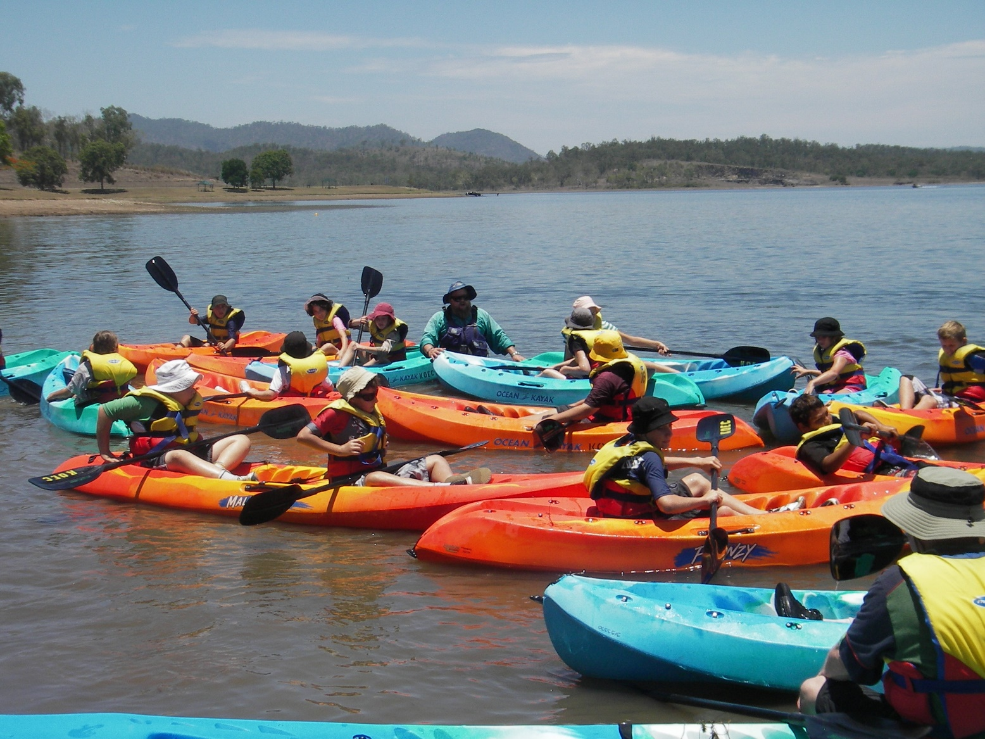
Activity Objective (Aim): Students will participate in a kayaking activity to strengthen their understanding of the core focus objectives that align with the school’s chosen program.

Program Core Focus Objectives
Resilience
Self Control
Avoid Frustration
Control their emotions appropriately
Optimism
Look at the bright side
Have a positive outlook
Have a sense of self-belief and remind themselves of the things they can do
Adaptable
Think ahead
Don’t blame others
Seek opportunities from failure
Perseverance
Give new tasks a go
When something doesn’t work the first time give it another go (be flexible)
Overcome obstacles
Evidence of Learning:
Resilience
Students can
- Identify situations that lead to stress
- Identify appropriate strategies to manage stress and regulate behaviour
- Implement appropriate strategies to manage stress and moderate emotions
- Understand the difference between appropriate and inappropriate emotions
- Understand the impact of their emotional responses on others
- Demonstrate appropriate emotions
- Identify situations where emotions can negatively impact on your actions
- Identify the positive in a given situation
- Perceive negative situations as opportunities for growth
- Reflect on smaller achievements rather than whether or not overall success was achieved
- Share achievements with others
- Use positive language to describe challenges
- Identify their own strengths
- Seek opportunities to develop strengths
- Use positive self-talk
- Set goals for personal learning
- Use a growth mindset
- Use prior knowledge to express possible solutions
- Determine what they want to plan for
- Identify previously learnt skills that could be used to reach a solution
- Identify and describe factors and strategies that assist in their learning
- Be accountable for their actions
- Seek solutions rather than blame
- Practise solving routine problems
- Learn from mistakes
- Analyse past attempts
- Predict the outcomes of personal and academic challenges by drawing on previous problem-solving and decision making strategies and feedback from peers and teachers
- Identify unfamiliar situations
- Undertake and persist with short tasks within the limits of personal safety
- Have the courage to try unfamiliar challenges
- Reflect on unfavourable outcomes to understand why results were not achieved
- Persist with tasks when faced with challenges
- Adapt their approach where first attempts were not successful
- Monitor and evaluate progress
- Seek and respond to feedback
- Analyse progress to reflect on possible solutions
- Devise strategies and formulate plans to assists in the completion of challenging tasks
- Identify situations that feel safe or seemingly unsafe, approaching new situations with confidence
- Identify own strength as well as group strengths that can be useful in achieving goals
Curriculum Links: Resilience
HPE |  | Mathematics
Personal Social and Community Health  Analyse factors that influence emotions, and develop strategies to demonstrate empathy and sensitivity. (ACPPS075)  Propose, practise and evaluate responses in situations where external influences may impact on their ability to make healthy and safe choices  (ACPPS092)  Investigate how empathy and ethical decision making contribute to respectful relationships  (ACPPS093)  Practise and apply strategies to seek help for themselves or others  (ACPPS072) |  | Statistics and Probability  Assign probabilities to the outcomes of events and determine probabilities for events  (ACMSP168)
General Capabilities
Personal and Social Capability |  |  | Critical and Creative Thinking
Self-awareness  • Recognise personal qualities and achievements  • Understand themselves as learners  • Develop reflective practice  • Recognise emotions  Self-management  • Express emotions appropriately  • Develop self-discipline and set goals  • Work independently and show initiative  • Become confident, resilient and adaptable |  |  | Inquiring – identifying, exploring and organising information and ideas  • Identify and clarify information and ideas  • Organise and process information  • Pose questions  Generating ideas, possibilities and actions  • Seek solutions and put ideas into action  • Imagine possibilities and connect ideas  Reflecting on thinking and processes  • Reflect on processes  • Transfer knowledge into new contexts  Analysing, synthesising and evaluating reasoning and procedures  • Apply logic and reasoning

