Biscuiting | Kinchant Dam Outdoor Education Centre
Activity Overview Years 4-6
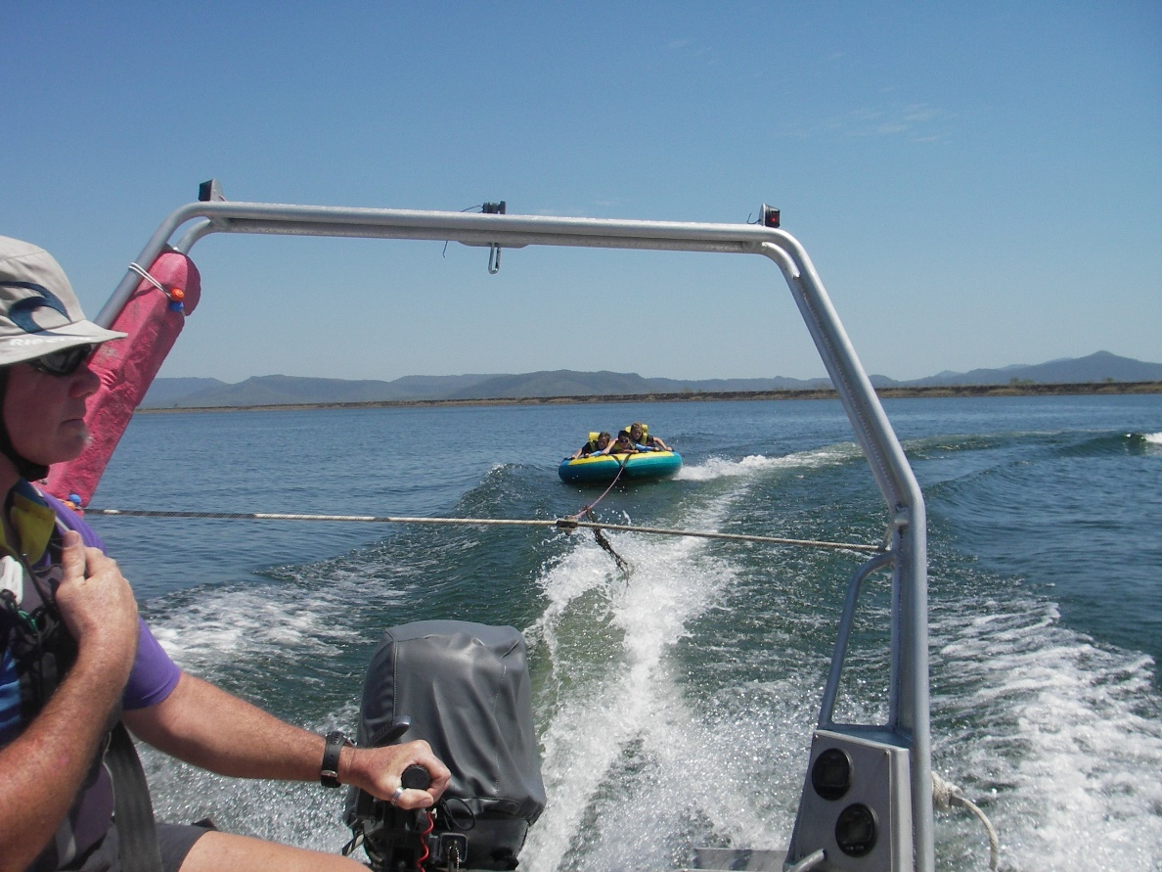
Activity Objective (Aim): Students will participate in a biscuiting activity session to strengthen their understanding of the core focus objectives that align with the school’s chosen program.

Program Core Focus Objectives
Resilience
Self Control
Avoid Frustration
Control their emotions appropriately
Optimism
Look at the bright side
Have a positive outlook
Have a sense of self-belief and remind themselves of the things they can do
Perseverance
Give new tasks a go
When something doesn’t work the first time give it another go (be flexible)
Overcome obstacles
Support
Ask for help
Be trustworthy and dependable
Take care of themselves and others, have social networks form where you can seek support

Evidence of Learning:
Resilience
Students can:
- Identify situations that lead to stress
- Identify appropriate strategies to manage stress and regulate behaviour
- Implement appropriate strategies to manage stress and moderate emotions
- Understand the difference between appropriate and inappropriate emotions
- Understand the impact of their emotional responses on others
- Demonstrate appropriate emotions
- Identify situations where emotions can negatively impact on your actions
- Identify the positive in a given situation
- Perceive negative situations as opportunities for growth
- Reflect on smaller achievements rather than whether or not overall success was achieved
- Share achievements with others
- Use positive language to describe challenges
- Identify their own strengths
- Seek opportunities to develop strengths
- Use positive self-talk
- Set goals for personal learning
- Use a growth mindset
- Identify unfamiliar situations
- Undertake and persist with short tasks within the limits of personal safety
- Have the courage to try unfamiliar challenges
- Reflect on unfavourable outcomes to understand why results were not achieved
- Persist with tasks when faced with challenges
- Adapt their approach where first attempts were not successful
- Monitor and evaluate progress
- Seek and respond to feedback
- Analyse progress to reflect on possible solutions
- Devise strategies and formulate plans to assists in the completion of challenging tasks
- Identify situations that feel safe or seemingly unsafe, approaching new situations with confidence
- Identify own strength as well as group strengths that can be useful in achieving goals
- Seek and respond to feedback
- Know who they can go to for help
- Ask an appropriate person for assistance
- Discuss elements of a task that they are unsure about
- Specifically articulate what they are seeking
- Identify positive ways to initiate conversations (interpersonal skills)
- Identify people and situations with which the feel a sense of familiarity or belonging
- Respond to the feelings, needs and interests of others
- Be cooperative
- Be sincere – say what you mean and mean what you say
- Be reliable
- Own up to mistakes

Curriculum Links: Teamwork, Leadership and Resilience
HPE |  | HASS
Examine how identities are influenced by people and places. (ACPPS051)  Examine the influence of emotional responses on behaviour and relationships.  (ACPPS056) |  | Examine information to identify different points of view and distinguish facts from opinions  (ACHASSI056)  Reflect on learning to propose actions in response to an issue or challenge and consider possible effects of proposed actions  (ACHASSI060)  The importance of making decisions democratically (ACHASSK070)  Interact with others with respect to share points of view. (ACHASSI059)  Examine information to identify different points of view and distinguish facts from opinions  (ACHASSI077)  Interact with others with respect to share points of view (ACHASSI080)  Work in groups to generate responses to issues and challenges  (ACHASSI102)  Work in groups to generate responses to issues and challenges  (ACHASSI130)
General Capabilities
Personal and Social Capability |  | Critical and Creative Thinking
Self-awareness  • Recognise personal qualities and achievements  • Understand themselves as learners  • Develop reflective practice  • Recognise emotions  Self-management  • Express emotions appropriately  • Develop self-discipline and set goals  • Become confident, resilient and adaptable  Social awareness  • Appreciate diverse perspectives  Social management  • Work collaboratively  • Make decisions |  | Inquiring – identifying, exploring and organising information and ideas  • Identify and clarify information and ideas  • Organise and process information  • Pose questions  Generating ideas, possibilities and actions  • Imagine possibilities and connect ideas  Reflecting on thinking and processes  • Reflect on processes  Analysing, synthesising and evaluating reasoning and procedures  • Apply logic and reasoning  • Evaluate procedures and outcomes

