Kinchant Dam Outdoor Education Centre
Team Challenge
Activity Overview Years F-2
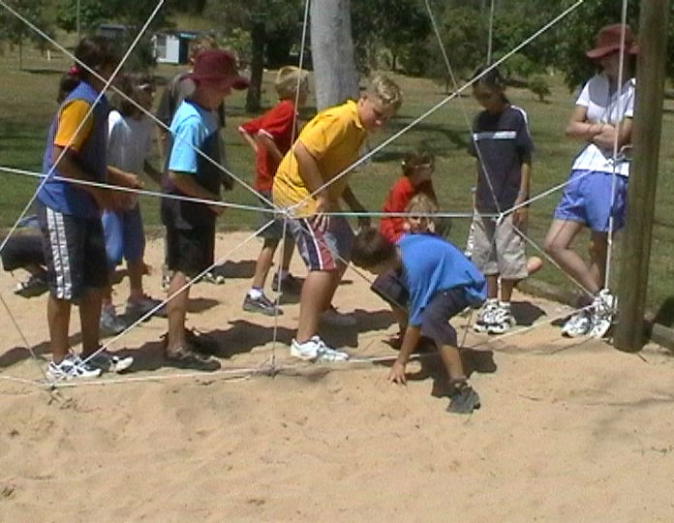
Activity Objective (Aim): Students will participate in a range of team challenge activities to strengthen their understanding of the core focus objectives that align with the school’s chosen program.

Program Core Focus Objectives
Team Work  Cooperation  Problem Solving  Negotiating  Decision Making  Participation  Team Roles and Responsibilities  Goal Setting  Reflecting  Respect  Accepting Diversity  Being Reliable  Building Trust  Communication  Active Listening  Speaking Clearly  Using Purposeful Discussion |  |  |  | Leadership  Responsible  Good Self-Management Skills  Using Good time Management  Being Accountable  Self-Confident  Knowing your Strengths and Weaknesses  Have Courage to Take Control  Support New and Innovative Strategies  Decisive  Using Effective Problem Solving Strategies  Creating a Plan  Being Decisive  Resourceful  Being Inclusive  Using the Teams Skills and Knowledge  Encouraging Initiative and Innovation |  |  |  |  | Resilience  Self Control  Avoid Frustration  Control their emotions appropriately  Put off small short term gains to achieve greater long term goals  Optimism  Look at the bright side  Have a positive outlook  Have a sense of self-belief and remind themselves of the things they can do  Adaptable  Think ahead  Don’t blame others  Seek opportunities from failure  Perseverance  Give new tasks a go  When something doesn’t work the first time give it another go (be flexible)  Overcome obstacles  Support  Ask for help  Be trustworthy and dependable  Take care of themselves and others, have social networks form where you can seek support
Evidence of Learning:
Team Work  Students can  - Analyse the problem  - Plan a solution  - Implement solutions  - Negotiate their personal limits  - Make informed personal decisions  - Reflect on their personal experience  - Set roles and responsibilities within their team  - Set goals to achieve greater personal targets  - Know their roles and responsibilities within the team  - Build trust amongst their group to ensure both physical and emotional safety  - Be trusted to complete their designated responsibilities  - Accept that different group members have different limitations  - Demonstrate purposeful listening  - Communicate effectively with team members |  |  | Leadership  Students can  - Think before they act  - List jobs that need to be done  - Prioritise tasks  - Break larger tasks into smaller, more manageable tasks  - Take actions to prevent or correct problems  - Accept responsibility  - Take care of their team  - Know what they are good at  - Know what they need help with  - Seek help from the right person  - Speak up when it is needed and listen all of the time  - Offer support and encouragement to their team  - Support new and exciting strategies  - Clearly understand the goal  - Collect all relevant information  - Consider how decisions will affect the team  - Consider the needs of the team  - Help people share their ideas  - Find relevant jobs for everyone involved  - Find out what people know and can do  - Help people share their thoughts and ideas |  |  |  |  | Resilience  Students can  - Identify situations that lead to stress  - Identify appropriate strategies to manage stress and regulate behaviour  - Implement appropriate strategies to manage stress and moderate emotions  - Understand the difference between appropriate and inappropriate emotions  - Understand the impact of their emotional responses on others  - Demonstrate appropriate emotions  - Identify situations where emotions can negatively impact on your actions  - Look at situations holistically  - Identify opportunities for goal setting  - Understand possible outcomes  - Identify personal strengths and challenges  - Make realistic assessments of personal strengths and abilities  - Set goals appropriately taking into account timelines, abilities and possible setbacks  - Reflect on personal strengths and achievements when assessing whether goals were met  - Differentiate between long and short term goals  - Identify benefits of achieving goals  - Identify the positive in a given situation  - Perceive negative situations as opportunities for growth  - Reflect on smaller achievements rather than whether or not overall success was achieved  - Share achievements with others  - Use positive language to describe challenges  - Identify their own strengths  - Seek opportunities to develop strengths  - Use positive self-talk  - Set goals for personal learning  - Use a growth mindset  - Use prior knowledge to express possible solutions  - Determine what they want to plan for  - Identify previously learnt skills that could be used to reach a solution  - Identify and describe factors and strategies that assist in their learning  - Be accountable for their actions  - Seek solutions rather than blame  - Practise solving routine problems  - Learn from mistakes  - Analyse past attempts  - Predict the outcomes of personal and academic challenges by drawing on previous problem-solving and decision making strategies and feedback from peers and teachers  - Identify unfamiliar situations  - Undertake and persist with short tasks within the limits of personal safety  - Have the courage to try unfamiliar challenges  - Reflect on unfavourable outcomes to understand why results were not achieved  - Persist with tasks when faced with challenges  - Adapt their approach where first attempts were not successful  - Monitor and evaluate progress  - Seek and respond to feedback  - Analyse progress to reflect on possible solutions  - Devise strategies and formulate plans to assists in the completion of challenging tasks  - Identify situations that feel safe or seemingly unsafe, approaching new situations with confidence  - Identify own strength as well as group strengths that can be useful in achieving goals  - Seek and respond to feedback  - Know who they can go to for help  - Ask an appropriate person for assistance  - Discuss elements of a task that they are unsure about  - Specifically articulate what they are seeking  - Identify positive ways to initiate conversations (interpersonal skills)  - Identify people and situations with which the feel a sense of familiarity or belonging  - Respond to the feelings, needs and interests of others  - Be cooperative  - Be sincere – say what you mean and mean what you say  - Be reliable  - Own up to mistakes  - Describe factors that contribute to positive relationships  - Identify and explain factors that influence effective communication  - Describe characteristics of cooperative behaviour  - Identify evidence of positive behaviour in group activities  - Assess the extent to which individual roles and responsibilities enhance group cohesion and the achievement of personal and group objectives  - Assess individual and group decision making processes
Curriculum Links: Teamwork, Leadership and Resilience
HPE |  | Science |  |  | Design and Technology |  | HASS |  |  | Mathematics
Personal Social and Community Health  Identify personal strengths  (ACPPS001)  Identify people and demonstrate protective behaviours and other actions that help keep themselves safe and healthy  (ACPPS003)  Identify and describe emotional responses people may experience in different situations  (ACPPS005)  Identify actions that promote health, safety and wellbeing  (ACPPS006)  Practise personal and social skills to interact positively with others  (ACPPS004)  Participate in play that promotes engagement with outdoor settings and the natural environment  (ACPPS007)  Movement and Physical Activity  Practise fundamental movement skills and movement sequences using different body parts  (ACPMP008)  Participate in games with and without equipment  (ACPMP009)  Cooperate with others when participating in physical activities (ACPMP012)  Test possible solutions to movement challenges through trial and error  (ACPMP013)  Follow rules when participating in physical activities  (ACPMP014)  Personal Social and Community Health  Describe their own strengths and achievements and those of others, and identify how these contribute to personal identities  (ACPPS015)  Identify and practise emotional responses that account for own and others’ feelings  (ACPPS020)  Recognise similarities and differences in individuals and groups, and explore how these are celebrated and respected (ACPPS024)  Perform fundamental movement skills in a variety of movement sequences and situations  (ACPMP025)  Recognise situations and opportunities to promote health, safety and wellbeing  (ACPPS018)  Movement and Physical Activity  Create and participate in games with and without equipment  (ACPMP027)  Propose a range of alternatives and test their effectiveness when solving movement challenges  (ACPMP031)  Identify rules and fair play when participating in physical activities  (ACPMP032)  Describe ways to include others to make them feel they belong  (ACPPS019)  Recognise similarities and differences in individuals and groups, and explore how these are celebrated and respected  (ACPPS024)  Use strategies to work in group situations when participating in physical activities  (ACPMP030) |  | Science Inquiry Skills  Pose and respond to questions, and make predictions about familiar objects and events  (ACSIS024)  Participate in guided investigations to explore and answer questions  (ACSIS025)  Compare observations with those of others  (ACSIS213)  Pose and respond to questions, and make predictions about familiar objects and events  (ACSIS037)  Participate in guided investigations to explore and answer questions  (ACSIS038)  Represent and communicate observations and ideas in a variety of ways (ACSIS029)  Compare observations with those of others  (ACSIS041) |  |  | Design and Technologies Processes and Production Skills  Use personal preferences to evaluate the success of design ideas, processes and solutions including their care for environment  (ACTDEP008)  Sequence steps for making designed solutions and working collaboratively (ACTDEP009) |  | Inquiry and Skills  Explore a point of view  (ACHASSI005)  Explore a point of view  (ACHASSI022)  Explore a point of view  (ACHASSI038)  Collect data and information from observations and identify information and data from sources provided  (ACHASSI002)  Collect data and information from observations and identify information and data from sources provided  (ACHASSI019)  Sequence familiar objects and events  (ACHASSI021)  Collect data and information from observations and identify information and data from sources provided  (ACHASSI035)  Sequence familiar objects and events  (ACHASSI037) |  |  | Number and Algebra  Sort and classify familiar objects and explain the basis for these classifications. Copy, continue and create patterns with objects and drawings  (ACMNA005)  Measurement and Geometry  Use direct and indirect comparisons to decide which is longer, heavier or holds more, and explain reasoning in everyday language  (ACMMG006)  Statistics and Probability  Identify outcomes of familiar events involving chance and describe them using everyday language such as ‘will happen’, ‘won’t happen’ or ‘might happen’  (ACMSP024)  Identify practical activities and everyday events that involve chance. Describe outcomes as ‘likely’ or ‘unlikely’ and identify some events as ‘certain’ or ‘impossible’ (ACMSP047)
General Capabilities
Personal and Social Capability |  |  |  |  |  | Critical and Creative Thinking
Appreciate diverse perspectives  - Understand relationships  Self-management  - Work independently and show initiative  - Develop self-discipline and set goals  - Become confident, resilient and adaptable  - Express emotions appropriately  Social management  - Make decisions  - Work collaboratively  - Negotiate and resolve conflict  - Understand relationships  Self-awareness  - Recognise personal qualities and achievements  - Understand themselves as learners  - Develop reflective practice  - Recognise emotions  Social awareness  - Appreciate diverse perspectives  - Understand relationships  - Appreciate diverse perspectives |  |  |  |  |  | Inquiring – identifying, exploring and organising information and ideas  - Identify and clarify information and ideas  - Organise and process information  - Pose questions  Generating ideas, possibilities and actions  - Seek solutions and put ideas into action  - Consider alternatives  - Imagine possibilities and connect ideas  - Evaluate procedures and outcomes  Reflecting on thinking and processes  - Transfer knowledge into new contexts  - Reflect on processes  - Think about thinking (metacognition)  Analysing, synthesising and evaluating reasoning and procedures  - Apply logic and reasoning  - Draw conclusions and design a course of action

