Adventure Games | Kinchant Dam Outdoor Education Centre
Activity Overview Years F-2
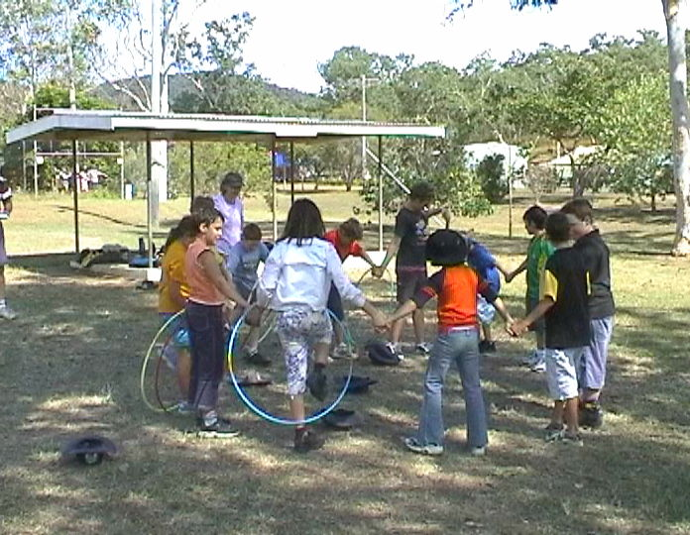
Activity Objective (Aim): Students will participate in adventure games to strengthen their understanding of the core focus objectives that align with the school’s chosen program.

Program Core Focus Objectives
Team Work  Cooperation  Negotiating  Decision Making  Participation  Team Roles and Responsibilities  Goal Setting  Reflecting  Respect  Accepting Diversity  Communication  Active Listening  Speaking Clearly |  |  | Resilience  Self Control  Avoid Frustration  Control their emotions appropriately  Put off small short term gains to achieve greater long term goals  Optimism  Look at the bright side  Have a positive outlook  Have a sense of self-belief and remind themselves of the things they can do  Adaptable  Think ahead  Don’t blame others  Seek opportunities from failure  Perseverance  Give new tasks a go  Overcome obstacles
Evidence of Learning:
Team Work  Students can  - Analyse the problem  - Plan a solution  - Implement solutions  - Negotiate their personal limits  - Make informed personal decisions  - Reflect on their personal experience  - Set roles and responsibilities within their team  - Set goals to achieve greater personal targets  - Know their roles and responsibilities within the team  - Build trust amongst their group to ensure both physical and emotional safety  - Accept that different group members have different limitations  - Demonstrate purposeful listening  - Communicate effectively with team members |  |  | Resilience  Students can  - Identify situations that lead to stress  - Identify appropriate strategies to manage stress and regulate behaviour  - Implement appropriate strategies to manage stress and moderate emotions  - Understand the difference between appropriate and inappropriate emotions  - Understand the impact of their emotional responses on others  - Demonstrate appropriate emotions  - Identify situations where emotions can negatively impact on your actions  - Look at situations holistically  - Identify opportunities for goal setting  - Understand possible outcomes  - Identify personal strengths and challenges  - Make realistic assessments of personal strengths and abilities  - Set goals appropriately taking into account timelines, abilities and possible setbacks  - Reflect on personal strengths and achievements when assessing whether goals were met  - Differentiate between long and short term goals  - Identify benefits of achieving goals  - Identify the positive in a given situation  - Perceive negative situations as opportunities for growth  - Reflect on smaller achievements rather than whether or not overall success was achieved  - Share achievements with others  - Use positive language to describe challenges  - Identify their own strengths  - Seek opportunities to develop strengths  - Use positive self-talk  - Set goals for personal learning  - Use a growth mindset  - Use prior knowledge to express possible solutions  - Determine what they want to plan for  - Identify previously learnt skills that could be used to reach a solution  - Identify and describe factors and strategies that assist in their learning  - Describe factors that contribute to positive relationships  - Identify and explain factors that influence effective communication  - Describe characteristics of cooperative behaviour  - Identify evidence of positive behaviour in group activities  - Assess the extent to which individual roles and responsibilities enhance group cohesion and the achievement of personal and group objectives  - Assess individual and group decision making processes
Curriculum Links: Teamwork and Resilience
HPE |  | Design and Technology |  | Mathematics
Identify people and demonstrate protective behaviours and other actions that help keep themselves safe and healthy  (ACPPS003)  Identify actions that promote health, safety and wellbeing  (ACPPS006)  Practise personal and social skills to interact positively with others (ACPPS004)  Participate in play that promotes engagement with outdoor settings and the natural environment  (ACPPS007)  Practise fundamental movement skills and movement sequences using different body parts  (ACPMP008)  Participate in games with and without equipment  (ACPMP009)  Cooperate with others when participating in physical activities (ACPMP012)  Test possible solutions to movement challenges through trial and error (ACPMP013)  Follow rules when participating in physical activities  (ACPMP014)  Describe their own strengths and achievements and those of others, and identify how these contribute to personal identities  (ACPPS015)  Identify and practise emotional responses that account for own and others’ feelings  (ACPPS020)  Perform fundamental movement skills in a variety of movement sequences and situations  (ACPMP025)  Recognise situations and opportunities to promote health, safety and wellbeing (ACPPS018)  Create and participate in games with and without equipment  (ACPMP027)  Propose a range of alternatives and test their effectiveness when solving movement challenges  (ACPMP031)  Identify rules and fair play when participating in physical activities (ACPMP032)  Describe ways to include others to make them feel they belong (ACPPS019)  Recognise similarities and differences in individuals and groups, and explore how these are celebrated and respected  (ACPPS024)  Discuss the body’s reactions to participating in physical activities (ACPMP028)  Use strategies to work in group situations when participating in physical activities  (ACPMP030) |  | Use personal preferences to evaluate the success of design ideas, processes and solutions including their care for environment  (ACTDEP008)  Sequence steps for making designed solutions and working collaboratively (ACTDEP009) |  | Sort and classify familiar objects and explain the basis for these classifications. Copy, continue and create patterns with objects and drawings  (ACMNA005)  Use direct and indirect comparisons to decide which is longer, heavier or holds more, and explain reasoning in everyday language  (ACMMG006)  Identify outcomes of familiar events involving chance and describe them using everyday language such as ‘will happen’, ‘won’t happen’ or ‘might happen’  (ACMSP024)  Investigate the effect of one-step slides and flips with and without digital technologies  (ACMMG045)
General Capabilities
Personal and Social Capability |  |  | Critical and Creative Thinking
Appreciate diverse perspectives  - Understand relationships  Self-management  - Work independently and show initiative  - Develop self-discipline and set goals  - Become confident, resilient and adaptable  - Express emotions appropriately  Social management  - Make decisions  - Work collaboratively  - Negotiate and resolve conflict  - Understand relationships  Self-awareness  - Recognise personal qualities and achievements  - Understand themselves as learners  - Develop reflective practice  - Recognise emotions  Social awareness  - Appreciate diverse perspectives  - Understand relationships  - Appreciate diverse perspectives |  |  | Inquiring – identifying, exploring and organising information and ideas  - Identify and clarify information and ideas  - Organise and process information  - Pose questions  Generating ideas, possibilities and actions  - Seek solutions and put ideas into action  - Consider alternatives  - Imagine possibilities and connect ideas  - Evaluate procedures and outcomes  Reflecting on thinking and processes  - Transfer knowledge into new contexts  - Reflect on processes  - Think about thinking (metacognition)  Analysing, synthesising and evaluating reasoning and procedures  - Apply logic and reasoning  - Draw conclusions and design a course of action

