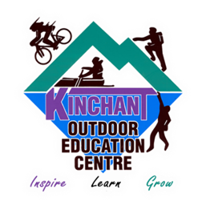  Adventure Games | Kinchant Dam Outdoor Education Centre
Activity Overview Years 7-10
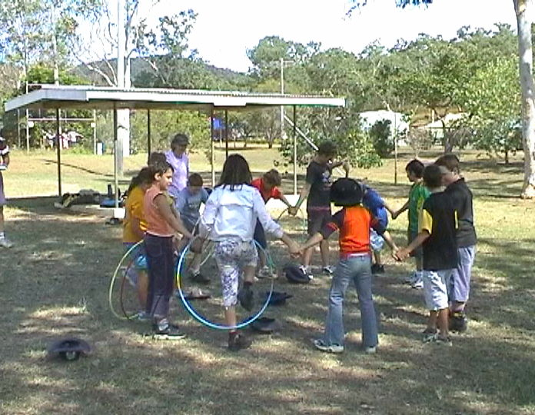
Activity Objective (Aim): Students will participate in adventure games to strengthen their understanding of the core focus objectives that align with the school’s chosen program.

Program Core Focus Objectives
Team Work  Cooperation  Negotiating  Decision Making  Participation  Team Roles and Responsibilities  Goal Setting  Reflecting  Respect  Accepting Diversity  Communication  Active Listening  Speaking Clearly |  |  | Resilience  Self Control  Avoid Frustration  Control their emotions appropriately  Put off small short term gains to achieve greater long term goals  Optimism  Look at the bright side  Have a positive outlook  Have a sense of self-belief and remind themselves of the things they can do  Adaptable  Think ahead  Don’t blame others  Seek opportunities from failure  Perseverance  Give new tasks a go  Overcome obstacles
Evidence of Learning:
Team Work  Students can  - Analyse the problem  - Plan a solution  - Implement solutions  - Negotiate their personal limits  - Make informed personal decisions  - Reflect on their personal experience  - Set roles and responsibilities within their team  - Set goals to achieve greater personal targets  - Know their roles and responsibilities within the team  - Build trust amongst their group to ensure both physical and emotional safety  - Accept that different group members have different limitations  - Demonstrate purposeful listening  - Communicate effectively with team members |  |  | Resilience  Students can  - Identify situations that lead to stress  - Identify appropriate strategies to manage stress and regulate behaviour  - Implement appropriate strategies to manage stress and moderate emotions  - Understand the difference between appropriate and inappropriate emotions  - Understand the impact of their emotional responses on others  - Demonstrate appropriate emotions  - Identify situations where emotions can negatively impact on your actions  - Look at situations holistically  - Identify opportunities for goal setting  - Understand possible outcomes  - Identify personal strengths and challenges  - Make realistic assessments of personal strengths and abilities  - Set goals appropriately taking into account timelines, abilities and possible setbacks  - Reflect on personal strengths and achievements when assessing whether goals were met  - Differentiate between long and short term goals  - Identify benefits of achieving goals  - Identify the positive in a given situation  - Perceive negative situations as opportunities for growth  - Reflect on smaller achievements rather than whether or not overall success was achieved  - Share achievements with others  - Use positive language to describe challenges  - Identify their own strengths  - Seek opportunities to develop strengths  - Use positive self-talk  - Set goals for personal learning  - Use a growth mindset  - Use prior knowledge to express possible solutions  - Determine what they want to plan for  - Identify previously learnt skills that could be used to reach a solution  - Identify and describe factors and strategies that assist in their learning  - Describe factors that contribute to positive relationships
Curriculum Links: Teamwork and Resilience
HPE |  | Design and Technology |  | Mathematics
Investigate the benefits to individuals and communities of valuing diversity and promoting inclusivity  (ACPPS079)  Demonstrate and explain how the elements of effort, space, time, objects and people can enhance movement sequences  (ACPMP084)  Evaluate and justify reasons for decisions and choices of action when solving movement challenges (ACPMP087)  Modify rules and scoring systems to allow for fair play, safety and inclusive participation  (ACPMP088)  Use feedback to improve body control and coordination when performing specialised movement skills in a variety of situations  (ACPMP080)  Practise and apply personal and social skills when undertaking a range of roles in physical activities  (ACPMP086)  Investigate how empathy and ethical decision making contribute to respectful relationships  (ACPPS093)  Develop, implement and evaluate movement concepts and strategies for successful outcomes with and without equipment  (ACPMP101)  Analyse the impact of effort, space, time, objects and people when composing and performing movement sequences  (ACPMP103)  Devise, implement and refine strategies demonstrating leadership and collaboration skills when working in groups or teams  (ACPMP105)  Transfer understanding from previous movement experiences to create solutions to movement challenges (ACPMP106)  Reflect on how fair play and ethical behaviour can influence the outcomes of movement activities  (ACPMP107) |  | Select and justify choices of materials, components, tools, equipment and techniques to effectively and safely make designed solutions  (ACTDEP037)  Investigate and make judgments on how the characteristics and properties of materials are combined with force, motion and energy to create engineered solutions  (ACTDEK043)  Investigate and make judgments on how the characteristics and properties of materials, systems, components, tools and equipment can be combined to create designed solutions (ACTDEK046) |  | Assign probabilities to the outcomes of events and determine probabilities for events  (ACMSP168)
General Capabilities
Personal and Social Capability |  |  | Critical and Creative Thinking
Appreciate diverse perspectives  - Understand relationships  Self-management  - Work independently and show initiative  - Develop self-discipline and set goals  - Become confident, resilient and adaptable  - Express emotions appropriately  Social management  - Make decisions  - Work collaboratively  - Negotiate and resolve conflict  - Understand relationships  Self-awareness  - Recognise personal qualities and achievements  - Understand themselves as learners  - Develop reflective practice  - Recognise emotions  Social awareness  - Appreciate diverse perspectives  - Understand relationships  - Appreciate diverse perspectives |  |  | Inquiring – identifying, exploring and organising information and ideas  - Identify and clarify information and ideas  - Organise and process information  - Pose questions  Generating ideas, possibilities and actions  - Seek solutions and put ideas into action  - Consider alternatives  - Imagine possibilities and connect ideas  - Evaluate procedures and outcomes  Reflecting on thinking and processes  - Transfer knowledge into new contexts  - Reflect on processes  - Think about thinking (metacognition)  Analysing, synthesising and evaluating reasoning and procedures  - Apply logic and reasoning  - Draw conclusions and design a course of action

