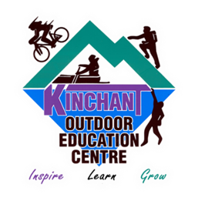  Adventure Games | Kinchant Dam Outdoor Education Centre
Activity Overview Years 3-6
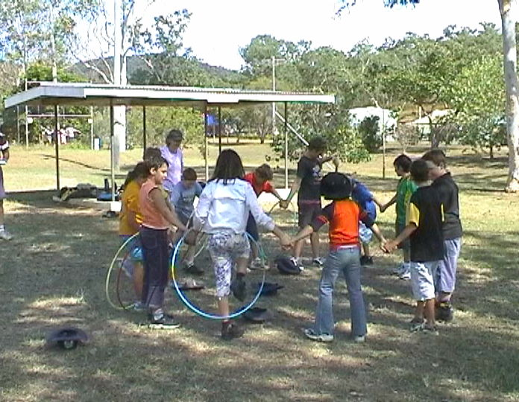
Activity Objective (Aim): Students will participate in adventure games to strengthen their understanding of the core focus objectives that align with the school’s chosen program.

Program Core Focus Objectives
Team Work  Cooperation  Negotiating  Decision Making  Participation  Team Roles and Responsibilities  Goal Setting  Reflecting  Respect  Accepting Diversity  Communication  Active Listening  Speaking Clearly |  |  | Resilience  Self Control  Avoid Frustration  Control their emotions appropriately  Put off small short term gains to achieve greater long term goals  Optimism  Look at the bright side  Have a positive outlook  Have a sense of self-belief and remind themselves of the things they can do  Adaptable  Think ahead  Don’t blame others  Seek opportunities from failure  Perseverance  Give new tasks a go  Overcome obstacles
Evidence of Learning:
Team Work  Students can  - Analyse the problem  - Plan a solution  - Implement solutions  - Negotiate their personal limits  - Make informed personal decisions  - Reflect on their personal experience  - Set roles and responsibilities within their team  - Set goals to achieve greater personal targets  - Know their roles and responsibilities within the team  - Build trust amongst their group to ensure both physical and emotional safety  - Accept that different group members have different limitations  - Demonstrate purposeful listening  - Communicate effectively with team members |  |  | Resilience  Students can  - Identify situations that lead to stress  - Identify appropriate strategies to manage stress and regulate behaviour  - Implement appropriate strategies to manage stress and moderate emotions  - Understand the difference between appropriate and inappropriate emotions  - Understand the impact of their emotional responses on others  - Demonstrate appropriate emotions  - Identify situations where emotions can negatively impact on your actions  - Look at situations holistically  - Identify opportunities for goal setting  - Understand possible outcomes  - Identify personal strengths and challenges  - Make realistic assessments of personal strengths and abilities  - Set goals appropriately taking into account timelines, abilities and possible setbacks  - Reflect on personal strengths and achievements when assessing whether goals were met  - Differentiate between long and short term goals  - Identify benefits of achieving goals  - Identify the positive in a given situation  - Perceive negative situations as opportunities for growth  - Reflect on smaller achievements rather than whether or not overall success was achieved  - Share achievements with others  - Use positive language to describe challenges  - Identify their own strengths  - Seek opportunities to develop strengths  - Use positive self-talk  - Set goals for personal learning  - Use a growth mindset  - Use prior knowledge to express possible solutions  - Determine what they want to plan for  - Identify previously learnt skills that could be used to reach a solution  - Identify and describe factors and strategies that assist in their learning  - Describe factors that contribute to positive relationships  - Identify and explain factors that influence effective communication  - Describe characteristics of cooperative behaviour  - Identify evidence of positive behaviour in group activities  - Assess the extent to which individual roles and responsibilities enhance group cohesion and the achievement of personal and group objectives  - Assess individual and group decision making processes
Curriculum Links: Teamwork and Resilience
HPE |  | Design and Technology |  | Mathematics
Explore strategies to manage physical, social and emotional change (ACPPS034)  Identify and practise strategies to promote health, safety and wellbeing (ACPPS036)  Describe how respect, empathy and valuing diversity can positively influence relationships  (ACPPS037)  Participate in outdoor games and activities to examine how participation promotes a connection between the community, natural and built environments, and health and wellbeing  (ACPPS041)  Apply innovative and creative thinking in solving movement challenges (ACPMP049)  Apply basic rules and scoring systems, and demonstrate fair play when participating in physical activities (ACPMP050)  Examine the benefits of physical activity to health and wellbeing  (ACPMP046)  Practise and apply movement concepts and strategies with and without equipment  (ACPMP045)  Adopt inclusive practices when participating in physical activities (ACPMP048)  Practise specialised movement skills and apply them in a variety of movement sequences and situations (ACPMP061)  Propose and apply movement concepts and strategies with and without equipment  (ACPMP063)  Participate in physical activities designed to enhance fitness, and discuss the impact regular participation can have on health and wellbeing (ACPMP064)  Manipulate and modify elements of effort, space, time, objects and people to perform movement sequences (ACPMP065)  Participate positively in groups and teams by encouraging others and negotiating roles and responsibilities (ACPMP067)  Demonstrate ethical behaviour and fair play that aligns with rules when participating in a range of physical activities  (ACPMP069)  Apply critical and creative thinking processes in order to generate and assess solutions to movement challenges  (ACPMP068)  Practise specialised movement skills and apply them in a variety of movement sequences and situations (ACPMP061)  Propose and apply movement concepts and strategies with and without equipment  (ACPMP063)  Participate in physical activities designed to enhance fitness, and discuss the impact regular participation can have on health and wellbeing (ACPMP064)  Manipulate and modify elements of effort, space, time, objects and people to perform movement sequences (ACPMP065)  Participate positively in groups and teams by encouraging others and negotiating roles and responsibilities (ACPMP067)  Demonstrate ethical behaviour and fair play that aligns with rules when participating in a range of physical activities  (ACPMP069) |  | Evaluate design ideas, processes and solutions based on criteria for success developed with guidance and including care for the environment  (ACTDEP017)  Plan a sequence of production steps when making designed solutions individually and collaboratively (ACTDEP018)  Negotiate criteria for success that include sustainability to evaluate design ideas, processes and solutions (ACTDEP027)  Investigate characteristics and properties of a range of materials, systems, components, tools and equipment and evaluate the impact of their use  (ACTDEK023)  Select appropriate materials, components, tools, equipment and techniques and apply safe procedures to make designed solutions (ACTDEP026) |  | Identify questions or issues for categorical variables. Identify data sources and plan methods of data collection and recording  (ACMSP068)  Compare and describe two dimensional shapes that result from combining and splitting common shapes, with and without the use of digital technologies (ACMMG088)  Describe possible everyday events and order their chances of occurring (ACMSP092)  Identify everyday events where one cannot happen if the other happens (ACMSP093)  Solve problems involving the comparison of lengths and areas using appropriate units  (ACMMG137)  Investigate combinations of translations, reflections and rotations, with and without the use of digital technologies  (ACMMG142)
General Capabilities
Personal and Social Capability |  |  | Critical and Creative Thinking
Appreciate diverse perspectives  - Understand relationships  Self-management  - Work independently and show initiative  - Develop self-discipline and set goals  - Become confident, resilient and adaptable  - Express emotions appropriately  Social management  - Make decisions  - Work collaboratively  - Negotiate and resolve conflict  - Understand relationships  Self-awareness  - Recognise personal qualities and achievements  - Understand themselves as learners  - Develop reflective practice  - Recognise emotions  Social awareness  - Appreciate diverse perspectives  - Understand relationships  - Appreciate diverse perspectives |  |  | Inquiring – identifying, exploring and organising information and ideas  - Identify and clarify information and ideas  - Organise and process information  - Pose questions  Generating ideas, possibilities and actions  - Seek solutions and put ideas into action  - Consider alternatives  - Imagine possibilities and connect ideas  - Evaluate procedures and outcomes  Reflecting on thinking and processes  - Transfer knowledge into new contexts  - Reflect on processes  - Think about thinking (metacognition)  Analysing, synthesising and evaluating reasoning and procedures  - Apply logic and reasoning  - Draw conclusions and design a course of action

