  Fishing |  | Kinchant Dam Outdoor Education Centre
Activity Overview Years 4-6
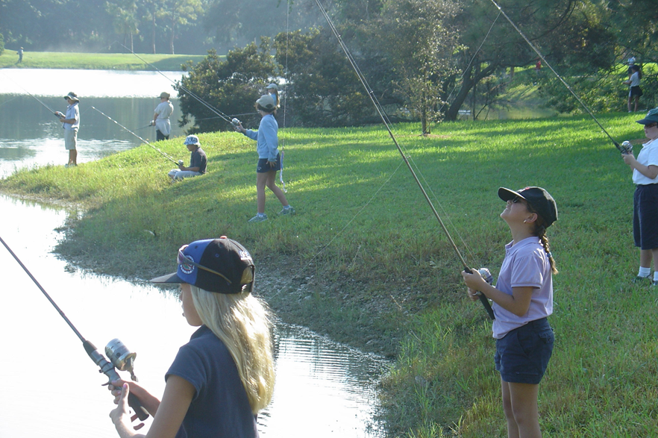
Activity Objective (Aim): Students will participate in a session of fishing to strengthen their understanding of the core focus objectives that align with the school’s chosen program.

Program Core Focus Objectives
Resilience
Self Control
Avoid Frustration
Control their emotions appropriately
Optimism
Look at the bright side
Have a positive outlook
Perseverance
Give new tasks a go
When something doesn’t work the first time give it another go (be flexible)
Overcome obstacles
Support
Ask for help
Be trustworthy and dependable
Take care of themselves and others, have social networks form where you can seek support
Evidence of Learning:
Resilience
Student can:
- Identify situations that lead to stress
- Identify appropriate strategies to manage stress and regulate behaviour
- Implement appropriate strategies to manage stress and moderate emotions
- Understand the difference between appropriate and inappropriate emotions
- Understand the impact of their emotional responses on others
- Demonstrate appropriate emotions
- Identify situations where emotions can negatively impact on your actions
- Identify the positive in a given situation
- Perceive negative situations as opportunities for growth
- Reflect on smaller achievements rather than whether or not overall success was achieved
- Share achievements with others
- Use positive language to describe challenges
- Identify unfamiliar situations
- Undertake and persist with short tasks within the limits of personal safety
- Have the courage to try unfamiliar challenges
- Reflect on unfavourable outcomes to understand why results were not achieved
- Persist with tasks when faced with challenges
- Adapt their approach where first attempts were not successful
- Monitor and evaluate progress
- Seek and respond to feedback
- Analyse progress to reflect on possible solutions
- Devise strategies and formulate plans to assists in the completion of challenging tasks
- Identify situations that feel safe or seemingly unsafe, approaching new situations with confidence
- Identify own strength as well as group strengths that can be useful in achieving goals
- Seek and respond to feedback
- Know who they can go to for help
- Ask an appropriate person for assistance
- Discuss elements of a task that they are unsure about
- Specifically articulate what they are seeking
- Identify positive ways to initiate conversations (interpersonal skills)
- Identify people and situations with which the feel a sense of familiarity or belonging
- Respond to the feelings, needs and interests of others
- Be cooperative
- Be sincere – say what you mean and mean what you say
- Be reliable
- Own up to mistakes
- Describe factors that contribute to positive relationships
- Identify and explain factors that influence effective communication
- Describe characteristics of cooperative behaviour
- Identify evidence of positive behaviour in group activities
- Assess the extent to which individual roles and responsibilities enhance group cohesion and the achievement of personal and group objectives
- Assess individual and group decision making processes
Curriculum Links: Resilience

HPE | Science |  | HASS | Mathematics
Explore how success, challenge and failure strengthen identities (ACPPS033)  Describe and apply strategies that can be used in situations that make them feel uncomfortable or unsafe (ACPPS035)  Investigate how emotional responses vary in depth and strength  (ACPPS038)  Examine the influence of emotional responses on behaviour and relationships  (ACPPS056) | scientifically and make predictions based on prior knowledge  (ACSIS064)  Compare results with predictions, suggesting possible reasons for findings  (ACSIS216) |  | Examine information to identify different points of view and distinguish facts from opinions (ACHASSI056)  Draw simple conclusions based on analysis of information and data. (ACHASSI058)  Interact with others with respect to share points of view  (ACHASSI059)  Interact with others with respect to share points of view  (ACHASSI080)  Evaluate evidence to draw conclusions  (ACHASSI129)  Use criteria to make decisions and judgements and consider advantages and disadvantages of preferring one decision over others  (ACHASSI131) | Identify everyday events where one cannot happen if the other happens  (ACMSP093)
General Capabilities
Personal and Social Capability |  |  |   Critical and Creative Thinking
Self-awareness  • Recognise personal qualities and achievements  • Understand themselves as learners  • Develop reflective practice  • Recognise emotions  Self-management  • Express emotions appropriately  • Develop self-discipline and set goals  • Work independently and show initiative  • Become confident, resilient and adaptable  Social awareness  • Appreciate diverse perspectives |  |  | (Inquiring – identifying, exploring and organising information and ideas  • Identify and clarify information and ideas  • Organise and process information  • Pose questions  Analysing, synthesising and evaluating reasoning and procedures  • Apply logic and reasoning  Analysing, synthesising and evaluating reasoning and procedures  • Draw conclusions and design a course of action  • Evaluate procedures and outcomes  Generating ideas, possibilities and actions  • Seek solutions and put ideas into action  Reflecting on thinking and processes  • Reflect on processes  • Draw conclusions and design a course of action

