Kinchant Dam Outdoor Education Centre
Archery
Activity Overview Years 5-6
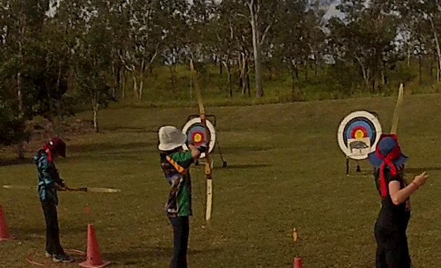
Activity Objective (Aim): Students will participate in an archery activity to strengthen their understanding of the core focus objectives that align with the school’s chosen program.

Program Core Focus Objectives
Resilience
Self Control
Avoid Frustration
Control their emotions appropriately
Optimism
Look at the bright side
Have a positive outlook
Have a sense of self-belief and remind themselves of the things they can do
Adaptable
Think ahead
Don’t blame others
Seek opportunities from failure
Perseverance
Give new tasks a go
When something doesn’t work the first time give it another go (be flexible)
Overcome obstacles

Evidence of Learning:
Resilience
- Identify situations that lead to stress
- Identify appropriate strategies to manage stress and regulate behaviour
- Implement appropriate strategies to manage stress and moderate emotions
- Understand the difference between appropriate and inappropriate emotions
- Understand the impact of their emotional responses on others
- Demonstrate appropriate emotions
- Identify situations where emotions can negatively impact on your actions
- Identify the positive in a given situation
- Perceive negative situations as opportunities for growth
- Reflect on smaller achievements rather than whether or not overall success was achieved
- Share achievements with others
- Use positive language to describe challenges
- Identify their own strengths
- Seek opportunities to develop strengths
- Use positive self-talk
- Set goals for personal learning
- Use a growth mindset
- Use prior knowledge to express possible solutions
- Determine what they want to plan for
- Identify previously learnt skills that could be used to reach a solution
- Identify and describe factors and strategies that assist in their learning
- Be accountable for their actions
- Seek solutions rather than blame
- Practise solving routine problems
- Learn from mistakes
- Analyse past attempts
- Predict the outcomes of personal and academic challenges by drawing on previous problem-solving and decision making strategies and feedback from peers and teachers
- Identify unfamiliar situations
- Undertake and persist with short tasks within the limits of personal safety
- Have the courage to try unfamiliar challenges
- Reflect on unfavourable outcomes to understand why results were not achieved
- Persist with tasks when faced with challenges
- Adapt their approach where first attempts were not successful

Curriculum Links: Resilience
HPE  Movement and Physical Activity  Practise specialised movement skills and apply them in different movement situations  (ACPMP080) |  | HASS  Inquiry and Skills  Reflect on learning to propose personal and/or collective action in response to an issue or challenge, and predict the probable effects  (ACHASSI104)  Reflect on learning to propose personal and/or collective action in response to an issue or challenge, and predict the probable effects  (ACHASSI132)
General Capabilities
Personal and Social Capability |  | Critical and Creative Thinking
Self-awareness  • Recognise personal qualities and achievements  • Understand themselves as learners  • Develop reflective practice  Self-management  • Develop self-discipline and set goals  • Work independently and show initiative  • Become confident, resilient and adaptable  Social management  • Work collaboratively  • Communicate effectively |  | Inquiring – identifying, exploring and organising information and ideas  • Identify and clarify information and ideas  - Pose questions  Reflecting on thinking and processes  • Reflect on processes  Analysing, synthesising and evaluating reasoning and procedures  • Apply logic and reasoning  Analysing, synthesising and evaluating reasoning and procedures  • Evaluate procedures and outcomes

