Orienteering | Kinchant Dam Outdoor Education Centre
Activity Overview Years 4-6
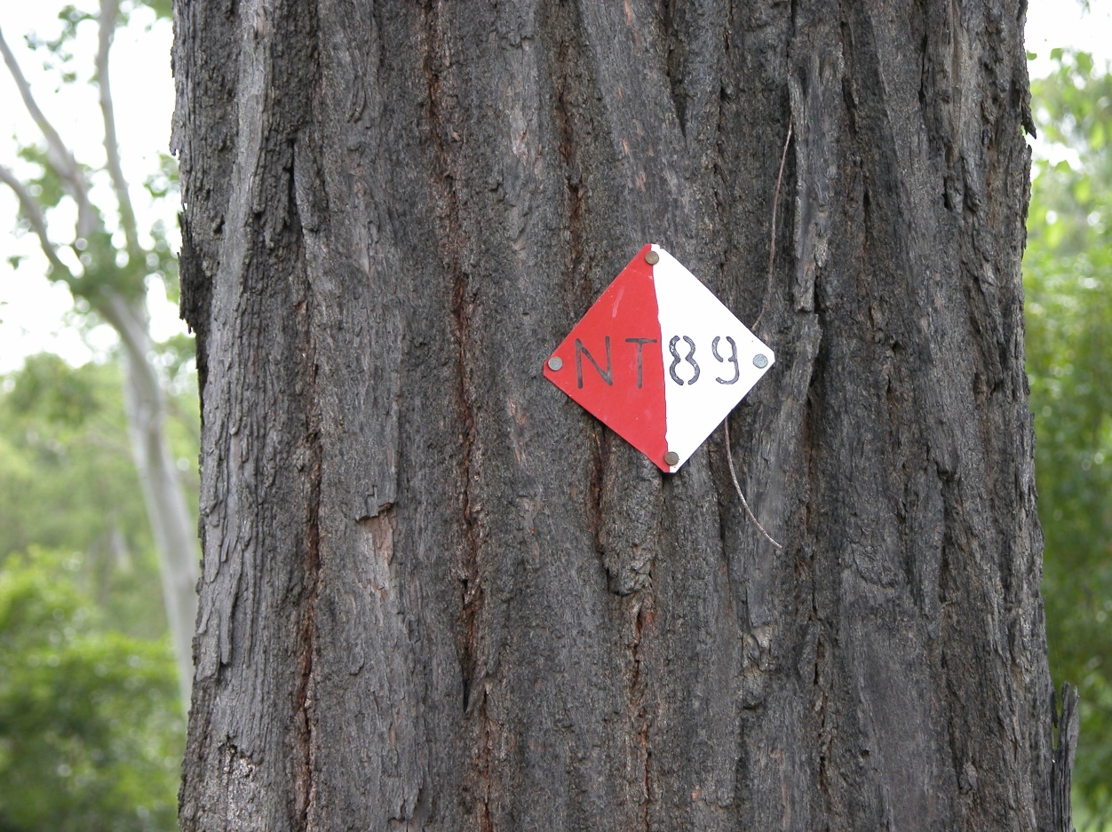
Activity Objective (Aim): Students will participate in an orienteering activity to strengthen their understanding of the core focus objectives that align with the school’s chosen program.

Program Core Focus Objectives
Leadership  Responsible  Using Good Self-Management Skills  Being Accountable  Self-Confident  Having Courage to Take Control  Knowing your Strengths and Weaknesses  Decisive  Being Decisive  Creating a Plan  Resourceful  Being Inclusive  Using the Team Skills and Knowledge |  | Resilience  Self Control  Avoid Frustration  Control their emotions appropriately  Optimism  Look at the bright side  Have a positive outlook  Have a sense of self-belief and remind themselves of the things they can do  Adaptable  Think ahead  Don’t blame others  Seek opportunities from failure  Perseverance  Give new tasks a go  When something doesn’t work the first time give it another go (be flexible)  Overcome obstacles  Support  Ask for help  Be trustworthy and dependable  Take care of themselves and others, have social networks form where you can seek support
Evidence of Learning:
Leadership  Students can  - Think before they act  - Make a list of jobs that need to be done  - Break large jobs into smaller tasks  - Take actions to prevent of correct problems  - Accept responsibility and don’t blame others  - Express what they are good at  - Express what they need help with  - Speak up when it is needed  - Establish routines  - Know who they can go to for help  - Support new and exciting strategies  - Offer support and encouragement to their team  - Clearly understand what is trying to be achieved  - Collect all appropriate information  - Believe that they are making the best decisions possible with the information that they have  - Set timelines  - Consider the needs of the team  - Help people share their ideas and thoughts  - Find out what people know and can do  - Find relevant jobs for everyone involved  - Encourage people to think and try new things |  | Resilience  Students can  - Identify situations that lead to stress  - Identify appropriate strategies to manage stress and regulate behaviour  - Implement appropriate strategies to manage stress and moderate emotions  - Understand the difference between appropriate and inappropriate emotions  - Understand the impact of their emotional responses on others  - Demonstrate appropriate emotions  - Identify situations where emotions can negatively impact on your actions  - Identify the positive in a given situation  - Perceive negative situations as opportunities for growth  - Reflect on smaller achievements rather than whether or not overall success was achieved  - Share achievements with others  - Use positive language to describe challenges  - Identify their own strengths  - Seek opportunities to develop strengths  - Use positive self-talk  - Set goals for personal learning  - Use a growth mindset  - Use prior knowledge to express possible solutions  - Determine what they want to plan for  - Identify previously learnt skills that could be used to reach a solution  - Identify and describe factors and strategies that assist in their learning  - Be accountable for their actions  - Seek solutions rather than blame  - Practise solving routine problems  - Learn from mistakes  - Analyse past attempts  - Predict the outcomes of personal and academic challenges by drawing on previous problem-solving and decision making strategies and feedback from peers and teachers  - Identify unfamiliar situations  - Undertake and persist with short tasks within the limits of personal safety  - Have the courage to try unfamiliar challenges  - Reflect on unfavourable outcomes to understand why results were not achieved  - Persist with tasks when faced with challenges  - Adapt their approach where first attempts were not successful  - Monitor and evaluate progress  - Seek and respond to feedback  - Analyse progress to reflect on possible solutions  - Devise strategies and formulate plans to assists in the completion of challenging tasks  - Identify situations that feel safe or seemingly unsafe, approaching new situations with confidence  - Identify own strength as well as group strengths that can be useful in achieving goals  - Seek and respond to feedback  - Know who they can go to for help  - Ask an appropriate person for assistance  - Discuss elements of a task that they are unsure about  - Specifically articulate what they are seeking  - Identify positive ways to initiate conversations (interpersonal skills)  - Identify people and situations with which the feel a sense of familiarity or belonging  - Respond to the feelings, needs and interests of others  - Be cooperative  - Be sincere – say what you mean and mean what you say  - Be reliable  - Own up to mistakes  - Describe factors that contribute to positive relationships  - Identify and explain factors that influence effective communication  - Describe characteristics of cooperative behaviour  - Identify evidence of positive behaviour in group activities  - Assess the extent to which individual roles and responsibilities enhance group cohesion and the achievement of personal and group objectives  - Assess individual and group decision making processes
Curriculum Links: Leadership and Resilience
HPE |  | Mathematics
Personal Social and Community Health  Explore how success, challenge and failure strengthen identities  (ACPPS033)  Explore strategies to manage physical, social and emotional change  (ACPPS034)  Describe and apply strategies that can be used in situations that make them feel uncomfortable or unsafe  (ACPPS035)  Describe how respect, empathy and valuing diversity can positively influence relationships  (ACPPS037)  Investigate how emotional responses vary in depth and strength  (ACPPS038)  Examine the influence of emotional responses on behaviour and relationships  (ACPPS056)  Identify how valuing diversity positively influences the wellbeing of the community  (ACPPS060)  Movement and physical activity  Adopt inclusive practices when participating in physical activities  (ACPMP048)  Apply basic rules and scoring systems, and demonstrate fair play when participating in physical activities (ACPMP050)  Participate positively in groups and teams by encouraging others and negotiating roles and responsibilities  (ACPMP067)  Demonstrate ethical behaviour and fair play that aligns with rules when participating in a range of physical activities  (ACPMP069) |  | Measurement and geometry  Create and interpret simple grid maps to show position and pathways  (ACMMG065)  Use simple scales, legends and directions to interpret information contained in basic maps  (ACMMG090)  Solve problems involving the comparison of lengths and areas using appropriate units  (ACMMG137)  Statistics and Probability  Describe possible everyday events and order their chances of occurring  (ACMSP092)
General Capabilities
Personal and Social Capability |  | Critical and Creative Thinking
Self-awareness  • Recognise personal qualities and achievements  • Understand themselves as learners  • Develop reflective practice  • Recognise emotions  Self-management  • Express emotions appropriately  • Develop self-discipline and set goals  • Work independently and show initiative  • Become confident, resilient and adaptable  • Express emotions appropriately  Social awareness  • Appreciate diverse perspectives  • Understand relationships  Social management  • Work collaboratively  • Make decisions  • Communicate effectively |  | Inquiring – identifying, exploring and organising information and ideas  • Identify and clarify information and ideas  • Organise and process information  • Pose questions  Generating ideas, possibilities and actions  • Consider alternatives  • Seek solutions and put ideas into action  • Imagine possibilities and connect ideas  Reflecting on thinking and processes  • Reflect on processes  • Transfer knowledge into new contexts  Analysing, synthesising and evaluating reasoning and procedures  • Apply logic and reasoning

