Kinchant Dam Outdoor Education Centre
Raft Building
Activity Overview Years 7-10
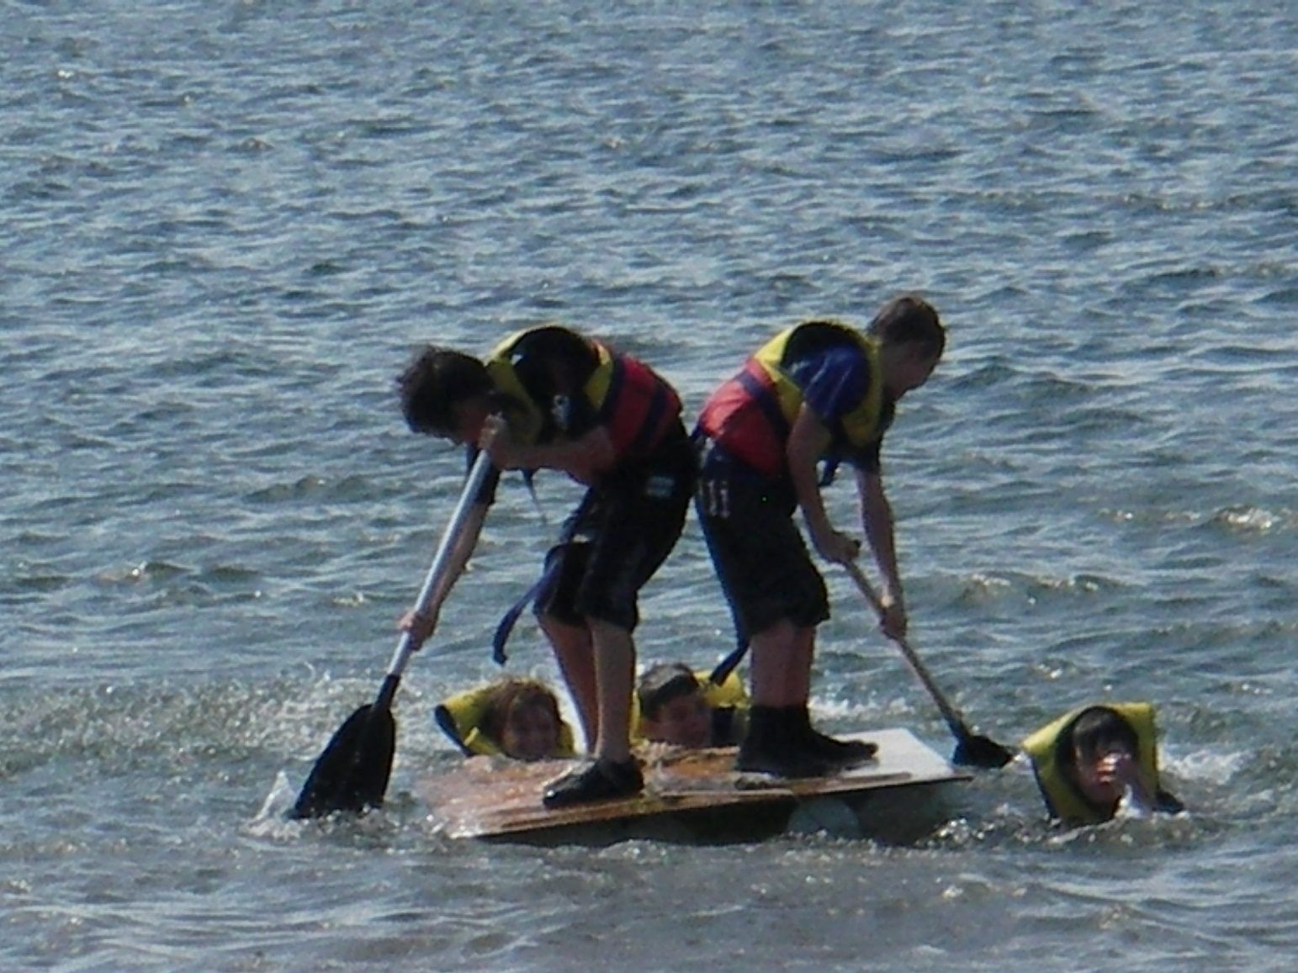
Activity Objective (Aim): Students will participate in a raft building activity session to strengthen their understanding of the core focus objectives that align with the school’s chosen program.

Program Core Focus Objectives
Team Work  Cooperation  Problem Solving  Negotiating  Decision Making  Participation  Team Roles and Responsibilities  Goal Setting  Reflecting  Respect  Being Reliable  Accepting Diversity  Communication  Active Listening  Speaking Clearly  Using Purposeful Discussion |  |  | Leadership  Responsible  Being Accountable  Good Self-Management Skills  Self-Confident  Knowing your strengths and Weaknesses  Having Courage to Take Control  Supporting New and Innovative Strategies  Decisive  Creating a Plan  Resourceful |  | Resilience  Self Control  Avoid Frustration  Control their emotions appropriately  Put off small short term gains to achieve greater long term goals  Optimism  Look at the bright side  Have a positive outlook  Have a sense of self-belief and remind themselves of the things they can do  Adaptable  Think ahead  Don’t blame others  Seek opportunities from failure  Perseverance  Give new tasks a go  When something doesn’t work the first time give it another go (be flexible)  Overcome obstacles  Support  Ask for help  Be trustworthy and dependable  Take care of themselves and others, have social networks form where you can seek support
Evidence of Learning:
Team Work  Students can  - Analyse the problem  - Plan a solution  - Implement solutions  - Negotiate their personal limits  - Make informed personal decisions  - Reflect on their personal experience  - Set roles and responsibilities within their team  - Set goals to achieve greater personal targets  - Know their roles and responsibilities within the team  - Build trust amongst their group to ensure both physical and emotional safety  - Be trusted to complete their designated responsibilities  - Accept that different group members have different limitations  - Demonstrate purposeful listening  - Communicate effectively with team members |  |  | Leadership  Students can  - Think before they act  - Take actions to prevent or correct problems  - Accept responsibility  - Take care of their team  - Know what they are good at  - Know what they need help with  - Seek help from the right person  - Speak up when it is needed and listen all of the time  - Clearly understand the goal  - Collect all relevant information  - Consider the needs of the team  - Help people share their ideas  - Find out what people know and can do  - Find relevant jobs for everyone involved  - Encourage people to think differently and try new things |  | Resilience  Students Can  - Identify situations that lead to stress  - Identify appropriate strategies to manage stress and regulate behaviour  - Implement appropriate strategies to manage stress and moderate emotions  - Understand the difference between appropriate and inappropriate emotions  - Understand the impact of their emotional responses on others  - Demonstrate appropriate emotions  - Identify situations where emotions can negatively impact on your actions  - Look at situations holistically  - Identify opportunities for goal setting  - Understand possible outcomes  - Identify personal strengths and challenges  - Make realistic assessments of personal strengths and abilities  - Set goals appropriately taking into account timelines, abilities and possible setbacks  - Reflect on personal strengths and achievements when assessing whether goals were met  - Differentiate between long and short term goals  - Identify benefits of achieving goals  - Identify the positive in a given situation  - Perceive negative situations as opportunities for growth  - Reflect on smaller achievements rather than whether or not overall success was achieved  - Share achievements with others  - Use positive language to describe challenges  - Identify their own strengths  - Seek opportunities to develop strengths  - Use positive self-talk  - Set goals for personal learning  - Use a growth mindset  - Use prior knowledge to express possible solutions  - Determine what they want to plan for  - Identify previously learnt skills that could be used to reach a solution  - Identify and describe factors and strategies that assist in their learning  - Be accountable for their actions  - Seek solutions rather than blame  - Practise solving routine problems  - Learn from mistakes  - Analyse past attempts  - Predict the outcomes of personal and academic challenges by drawing on previous problem-solving and decision making strategies and feedback from peers and teachers  - Identify unfamiliar situations  - Undertake and persist with short tasks within the limits of personal safety  - Have the courage to try unfamiliar challenges  - Reflect on unfavourable outcomes to understand why results were not achieved  - Persist with tasks when faced with challenges  - Adapt their approach where first attempts were not successful  - Monitor and evaluate progress  - Seek and respond to feedback  - Analyse progress to reflect on possible solutions  - Devise strategies and formulate plans to assists in the completion of challenging tasks  - Identify situations that feel safe or seemingly unsafe, approaching new situations with confidence  - Identify own strength as well as group strengths that can be useful in achieving goals  - Seek and respond to feedback  - Know who they can go to for help  - Ask an appropriate person for assistance  - Discuss elements of a task that they are unsure about  - Specifically articulate what they are seeking  - Identify positive ways to initiate conversations (interpersonal skills)  - Identify people and situations with which the feel a sense of familiarity or belonging  - Respond to the feelings, needs and interests of others  - Be cooperative  - Be sincere – say what you mean and mean what you say  - Be reliable  - Own up to mistakes  - Describe factors that contribute to positive relationships  - Identify and explain factors that influence effective communication  - Describe characteristics of cooperative behaviour  - Identify evidence of positive behaviour in group activities  - Assess the extent to which individual roles and responsibilities enhance group cohesion and the achievement of personal and group objectives  - Assess individual and group decision making processes
Curriculum Links: Teamwork, Leadership and Resilience
HPE | Science |  |  | Design and Technology |  | HASS
Personal Social and Community Health  Practise and apply strategies to seek help for themselves or others (ACPPS072)  Analyse factors that influence emotions, and develop strategies to demonstrate empathy and sensitivity  (ACPPS075)  Investigate the benefits to individuals and communities of valuing diversity and promoting inclusivity  (ACPPS079)  Propose, practise and evaluate responses in situations where external influences may impact on their ability to make healthy and safe choices (ACPPS092)  Investigate how empathy and ethical decision making contribute to respectful relationships (ACPPS093)  Movement and Physical Activity  Demonstrate and explain how the elements of effort, space, time, objects and people can enhance movement sequences (ACPMP084)  Practise and apply personal and social skills when undertaking a range of roles in physical activities  (ACPMP086)  Evaluate and justify reasons for decisions and choices of action when solving movement challenges  (ACPMP087)  Modify rules and scoring systems to allow for fair play, safety and inclusive participation  (ACPMP088)  Develop, implement and evaluate movement concepts and strategies for successful outcomes with and without equipment  (ACPMP101)  Analyse the impact of effort, space, time, objects and people when composing and performing movement sequences  (ACPMP103)  Devise, implement and refine strategies demonstrating leadership and collaboration skills when working in groups or teams  (ACPMP105)  Transfer understanding from previous movement experiences to create solutions to movement challenges  (ACPMP106)  Reflect on how fair play and ethical behaviour can influence the outcomes of movement activities (ACPMP107) | Science Inquiry Skills  Use knowledge of scientific concepts to draw conclusions that are consistent with evidence (ACSIS170)  Critically analyse the validity of information in primary and secondary sources and evaluate the approaches used to solve problems  (ACSIS172)  Critically analyse the validity of information in primary and secondary sources, and evaluate the approaches used to solve problems  (ACSIS206) |  |  | Design and Technologies Processes and Production Skills  Analyse ways to produce designed solutions through selecting and combining characteristics and properties of materials, systems, components, tools and equipment  (ACTDEK034)  Independently develop criteria for success to evaluate design ideas, processes and solutions and their sustainability (ACTDEP038)  Select and justify choices of materials, components, tools, equipment and techniques to effectively and safely make designed solutions  (ACTDEP037)  Use project management processes when working individually and collaboratively to coordinate production of designed solutions (ACTDEP039)  Develop, modify and communicate design ideas by applying design thinking, creativity, innovation and enterprise skills of increasing sophistication (ACTDEP049) |  | Civics and Citizenship Skills  Appreciate multiple perspectives and use strategies to mediate differences  (ACHCS057)  Appreciate multiple perspectives and use strategies to mediate differences  (ACHCS071)  Account for different interpretations and points of view  (ACHCS085)  Recognise and consider multiple perspectives and ambiguities, and use strategies to negotiate and resolve contentious issues  (ACHCS086)  Account for different interpretations and points of view  (ACHCS098)  Recognise and consider multiple perspectives and ambiguities, and use strategies to negotiate and resolve contentious issues  (ACHCS099)
General Capabilities
Personal and Social Capability |  |  |  | Critical and Creative Thinking
Self-awareness  • Recognise personal qualities and achievements  • Understand themselves as learners  • Develop reflective practice  • Recognise emotions  Self-management  • Express emotions appropriately  • Develop self-discipline and set goals  • Work independently and show initiative  • Become confident, resilient and adaptable  Social awareness  • Appreciate diverse perspectives  Social management  • Make decisions  • Work collaboratively  • Become confident, resilient and adaptable  • Make decisions |  |  |  | Inquiring – identifying, exploring and organising information and ideas  - Identify and clarify information and ideas  - Organise and process information  - Pose questions  Generating ideas, possibilities and actions  - Seek solutions and put ideas into action  - Imagine possibilities and connect ideas  - Consider alternatives  Reflecting on thinking and processes  - Reflect on processes  - Transfer knowledge into new contexts  Analysing, synthesising and evaluating reasoning and procedures  - Apply logic and reasoning  - Draw conclusions and design a course of action  - Evaluate procedures and outcomes

